

Lutley Primary School PTFA
Autumn Newsletter 2023

It has been great to see everyone back at school and we have already been able to hold the first batch of PTFA after school discos. We hope you all have had a great half term and are ready for the next few weeks leading up to the Christmas break.
In October we held our annual general meeting, where we said thanks to our stepping down committee, Ashleigh Nicholls (Chair), Steve Gill (Secretary) and Becky Cresser (Treasurer). All three have been involved with the PTFA for several years and have helped to raise an incredible £30,000 by putting on various PTFA events. Thank you so much for all your time you have given to the roles. Annabel Smith (Chair) and Rachel Tyson (Treasurer) have been voted in, with our secretary role to be filled at the next meeting. The first thing we wanted to share with you was all the fantastic fundraising that the PTFA were able to put on over the last 12 months.
During the last school year, with your help, we manged to raise an incredible £7500! This is such a great achievement, and we would like to thank each of you for your continued support. We would like to take this opportunity to thank Mrs Keen, Mrs Daley, Mr Hall, all the teaching and support staff for their support and for allowing us to hold these events. We look forward to the next 12 months of fundraising events.
We have held PTFA after school discos, the children designed their Christmas cards and Coronation Mugs, we held an Easter raffle, a summer fair, the children in EYFS were able to create their own self-portraits for their EYFS T-Towel and we continue to put on our half-termly pre-loved uniform sales giving parents an opportunity to donate unrequired pre-loved uniform for others to purchase for a fraction of the cost when bought in the shops.
During the school year we spent £6500, so we have a slight head start to this year which is great. This money was used to fund a variety of items for the children and the school including a visit from a pantomime production last Christmas, we provided funds for forest school works to be undertaken, with the addition of their new wooden shelter and continued to fund equipment required throughout the year. Finally, we gifted each child a King’s Coronation bookmark to celebrate the coronation of King Charles III.
As we said goodbye to the year 6 leavers at their leavers’ assembly, we were able to gift each child a leaver’s hoodie and autograph book as a keepsake of their time at Lutley Primary School. To help them celebrate their final few days, Antonio’s popped along to provide them their ice cream treats, paid for by the PTFA. We hope they have been enjoying the start of their new chapter at their new schools.
We now start the fundraising process again this year to raise another £7500 with your help. We have already held the first of our PTFA after school discos raising an incredible £1500, and as we write this update, the Christmas card designs are being printed ready to be handed out in November. Once again, the children have produced some wonderful designs, and we can’t wait for you to see them arrive as a Mug / T-towel / tote bag / teddy / Christmas bauble and even wrapping paper.
Even though the deadline for orders has passed, we have been given an additional 7-day window for any final orders. This will open on FRIDAY 17th until THURSDAY 23rd November. Once this deadline has passed, no more orders can be made. Please go to the website on the proof card and validate the design before you place the order.
Our next fundraiser will be our PTFA Christmas Fair on Saturday 2nd December. We have decided to run a Christmas Fair where the children can see Santa, and the whole family can enjoy breakfast if they wish, provided by Herons Gate Farm. There will be a range of school stalls, craft fair stalls, our pre-loved uniform will be available to purchase, and a special visitor will be coming to see us in our grotto to bring the children a special gift. Please see the PTFA Christmas Fair poster for more information. We look forward to seeing you all there. If you have any spare Christmas decorations that you no longer need, please bring them into school and put into the uniform drop off box by Wednesday 29th November, so we can utilise them for this event.
There is something we are asking all the children to help us with in exchange for wearing their own clothes for the day. Please see information about our PTFA Christmas mufti-day.
In the new year we continue to hold our pre-loved uniform sale, our next batch of PTFA after school discos, and if we can, a family fun quiz night (watch out for notifications on Parent Mail). That’s it for now, but if you would like to find out a bit more about what we do and have an hour a month to attend our online meetings, please contact ptfa@lutley.dudley.sch.uk for more information. The next one is Tuesday 14th November at 7pm, we hope to see some new faces join us.
Happy Autumn Term Everyone!

The Lutley Primary School PTFA team
PTFA upcoming events Autumn Term 2023
PTFA CHRISTMAS MUFTI DAY
We are inviting all the children to take part in our
PTFA Christmas Mufti Day on Friday 1st December.
To take part, each child will need to bring in EITHER
A filled, decorated Jolly ‘Jam’ Jar
(Any type of jar can be used if it is cleaned out.
If including sweets, these must be wrapped)
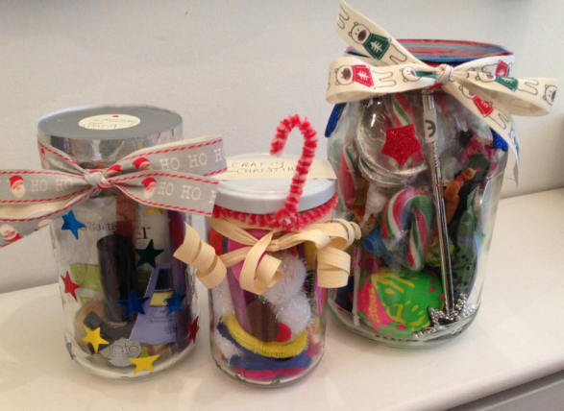
OR
A prize to go on our Christmas Tombola Stall.
(Boxes of chocolates, smellies, bubbly, toys etc)
Items can be brought in on the morning of the
1st December and handed to the class teacher.

All items will be used at our Christmas Fair event on Saturday 2nd December.
PTFA CHRISTMAS FAIR
SATURDAY 2nd December 9am-1pm
(Due to unforeseen circumstances, this replaces Breakfast with Santa)
EVERYONE IS WELCOME!
This Christmas, we will be holding a PTFA Christmas Fair in the Shakespeare Hall along with a Christmas Craft Fair.
We have the following stalls attending:
Cakes by Jenny at Cupcake Daze
Wax melts from Scents by Jenni
Candy floss by Magical Events
Gifts by Bella’s Crafts
Christmas wreaths by Little Gems Home Crafts
Glitter tattoos by Bling & Glitz
to name just a few…. Not only that, but we have
breakfast and hot drinks available to purchase from

Our special guest will be visiting our Grotto from 9am and will bring gifts for the children.
(These will be available to the first 250 children who attend)

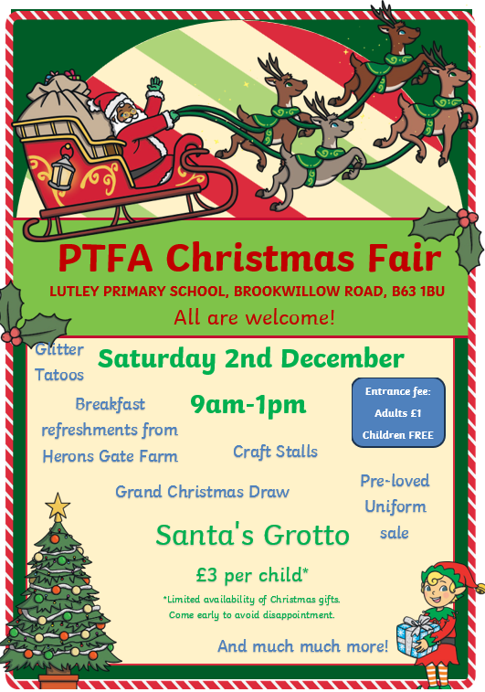

If you have any questions, please email
ptfa@lutley.dudley.sch.uk for more information.
Thank you all for your continued support.

