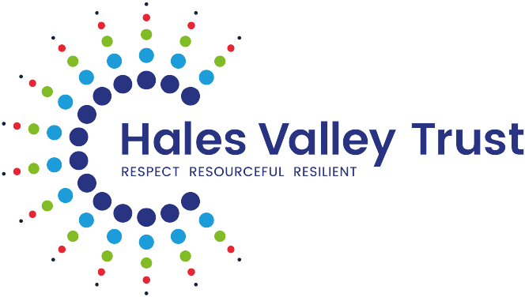

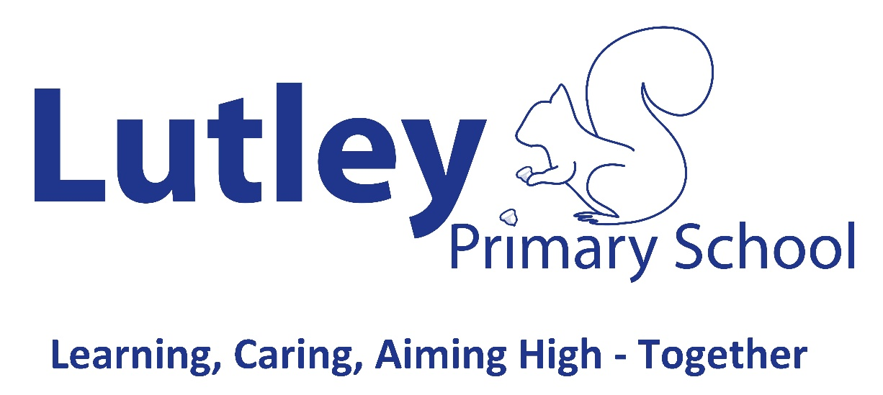
Behaviour Policy
Policy Tracker
Responsibility for monitoring this policy: Executive Headteachers/ Headteachers
Date | Reviewed by | Role | Date approved by Curriculum and Standards Committee
June 2025 | Alex Hall / Holly Ashton | Headteacher / Deputy Headteacher | June 2025
January 2026 | Alex Hall | Headteacher | Update approved via DOE 09/01/2026

Contents

Introduction
At Lutley Primary School we are committed to fostering a positive, safe, and respectful learning environment where all pupils can thrive. Our behaviour policy outlines the expectations for behaviour, the support we provide to help pupils meet these expectations, and the steps we take when things go wrong. This policy is designed to ensure consistency in how we manage behaviour, support pupils’ well-being, and promote positive relationships among all members of the school community. We believe that by working together - staff, pupils, and parents - we can create a school environment where every child feels safe, valued, and respected.
Legal Framework and Guidance
This policy has due regard to statutory legislation, including but not limited to, the following:
- The Education Act 2011
- The Equality Act 2010
- The Education and Inspections Act 2006
- The School Information (England) Regulations 2008, and the amendments made in 2012 (as amended)
- Keeping Children Safe in Education 2024
- DfE Behaviour in Schools 2024
- DfE Suspension and permanent exclusion from maintained schools, academies and pupil referral units in England, including pupil movement Guidance for maintained schools, academies, and pupil referral units in England 2024
- Department for Education's Searching, Screening and Confiscation at School guidance.
- Dudley: Inclusive Pathways Reducing the need to exclude through developing inclusive practices
- Dudley: Ordinarily Available Guidance

Linked Policies
Our Behaviour Policy connects with multiple other school-based policies to ensure consistency, legal compliance, and pupil support, such as:
- Safeguarding and Child Protection Policy
- SEND (Special Educational Needs and Disabilities) Policy
- Equality and Diversity Policy
- Accessibility Plan
- Teaching and Learning Policy
- Personal, Social, Health and Economic (PSHE) Education Policy
- Relationships and Sex Education (RSE) Policy
- Attendance Policy
- Health and Safety Policy
- Mental Health and Wellbeing Policy
- Staff Code of Conduct.
- Home-School Agreement
- Online Safety (E-Safety) Policy
- Acceptable Use Policy (AUP)
- Anti-Bullying and Prejudiced Related Incidents Policy
- Complaints Policy

Creating and Maintaining High Standards of Behaviour
The Headteacher takes responsibility for implementing measures to secure acceptable standards of behaviour. They ensure the school’s approach to behaviour meets the following national expectations:
- the school has high expectations of pupils’ conduct and behaviour, which is commonly understood by staff and pupils and applied consistently and fairly to help create a calm and safe environment;
- school leaders visibly and consistently support all staff in managing pupil behaviour through following the behaviour policy;
- measures are in place and both general and targeted interventions are used to improve pupil behaviour and support is provided to all pupils to help them meet behaviour standards, making reasonable adjustments for pupils with a disability as required;
- pupil behaviour does not normally disrupt teaching, learning or school routines. Disruption is not tolerated, and proportionate action is taken to restore acceptable standards of behaviour;
- all members of the school community create a positive, safe environment in which bullying, physical threats or abuse and intimidation are not tolerated, in which pupils are safe and feel safe and everyone is treated respectfully; and
- any incidents of bullying, discrimination, aggression, and derogatory language (including name calling) are dealt with quickly and effectively.
Establishing and maintaining high standards of behaviour is not only vital in ensuring that teachers can deliver the curriculum, but also plays a critical role in ensuring that our school is a safe environment for all pupils. As a result, all staff are aware of the measures outlined in our behaviour policy and how they should implement these. Where circumstances arise that endanger the safety of a pupil or staff member, the school acts swiftly and decisively to remove the threat and reduce the likelihood of its reoccurrence.
Our School Culture and Values
Our school values are: Learning, Caring, Aiming High – Together.
Our school’s culture and values are manifested through the behaviour of all the school community. High standards and clear rules reflect the values of our school and outline the expectations and consequences of behaviour for everyone.
In our school, we:
- encourage good behaviour and respect for others;
- secure an acceptable standard of behaviour of pupils;
- promote, among pupils, self-discipline and proper regard for authority;
- prevent all forms of bullying (including cyberbullying, prejudice-based and discriminatory bullying).

At our schools, we believe that the foundation of a strong behaviour culture begins with the adults. As Paul Dix powerfully states, “When the adults change, everything changes.” This principle underpins our approach to behaviour: it is the consistency, calmness, and compassion of adults that shape the climate of our classrooms and corridors. We understand that children can learn how to behave by watching how we behave. As a result, we model the respect, patience, and emotional regulation we expect from our pupils. We do not rely on raised voices or public reprimands, but instead use relational practice, clear routines, and restorative conversations to guide behaviour. We know that consistency is not about being rigid- it is about being relentlessly predictable in our expectations and responses. Every adult in our school community is empowered to build positive relationships, respond with empathy, and hold firm boundaries. By changing our own habits, language, and mindset, we create the conditions for every child to feel safe, respected, and ready to learn.

Communicating the Behaviour Policy
Communicating the school policy to all members of the community is an important way to build and maintain the school’s culture. It helps our school make the behaviour expectations transparent to all pupils, parents, and staff members, and provides reassurance that expectations of, and responses to, behaviour are consistent, fair, proportionate, and predictable. As a result, we communicate this policy and the Antibullying and Prejudice Related Incidents Policy to parents at least annually, and refer to both documents when managing and dealing with behaviour incidents.

Our School Behaviour Curriculum
At our school, we believe that positive behaviour is essential for a happy and successful learning environment. It reflects our school values, shows that we are ready to learn, and helps us treat others with kindness and respect. We create a setting where good behaviour is expected, encouraged, and celebrated - and where poor behaviour is less likely to happen.
We know that pupils need to be taught how to behave. That is why we have a clear behaviour curriculum, which helps everyone understand the behaviours we expect to see every day. It focuses on what good behaviour looks like, such as lining up quietly, listening when someone is speaking, and moving around the school safely and sensibly. Rather than just saying what pupils must not do, we focus on the positive habits and routines that help everyone feel safe and ready to learn.
We teach these behaviours through consistent routines and regular practice. For example, we show pupils how to enter the classroom calmly, how to work with others, and how to tidy up after lunch. These routines are simple, clear, and used across the school so that pupils always know what is expected.
When pupils meet expectations, we use positive reinforcement such as praise, rewards, and recognition to encourage them. When rules are not followed, we apply fair and appropriate consequences to help pupils learn and make better choices next time. Both are important in helping our pupils understand right from wrong and grow into responsible, respectful individuals.
We understand that some pupils may need extra help to meet behaviour expectations. We make reasonable adjustments when needed, for example, giving a pupil who has experienced a difficult event some space and support. We also consider the needs of pupils with Special Educational Needs and/or Disabilities (SEND), and plan support carefully to help them succeed.
At our school, we use consistent, clear, and calm language when talking about behaviour. This helps pupils understand what is expected and feel confident in making good choices.
Our Whole-School Approach to Behaviour
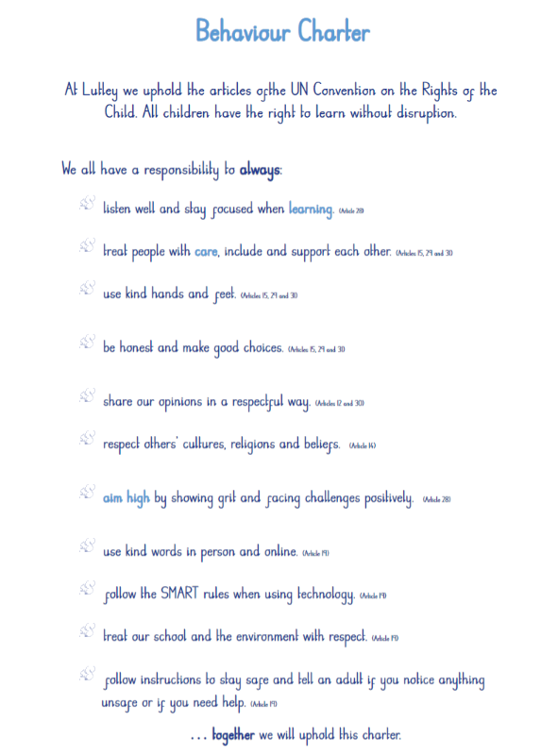
At our school, we believe that good behaviour is something we learn together. We take a whole-school approach, which means that everyone - pupils, staff and families - works as a team to create a kind, respectful and safe environment where everyone can thrive.
We know that pupils need to be taught how to behave, just like they learn to read or write. We do this by building caring, positive relationships between adults and pupils, setting clear and consistent expectations, and helping pupils understand why behaviour matters. We use positive language and praise to encourage the behaviours we want to see and help pupils feel confident and motivated to do their best.
We teach routines and expectations explicitly and practise them regularly so that pupils know exactly what is expected in different parts of the school day, such as coming into class, moving around the school, or listening during a lesson. This helps pupils feel safe and secure because they understand what will happen next and what is expected of them.
Pupils are also taught about the power of their choices and the consequences that follow. We help them understand that good choices bring positive outcomes, while poor choices may lead to consequences that help them learn and grow. When mistakes happen, we respond fairly and calmly, using them as learning opportunities to help pupils improve their behaviour over time.
By teaching behaviour in this way and using a consistent and fair approach across the whole school, we create a happy, respectful environment where everyone can feel confident, included and ready to learn.
Supporting Parents to Promote Positive Behaviour at Home
We actively support parents and carers to reinforce positive behaviour at home. By working in partnership, we can provide consistency and clarity for every child. We offer workshops, information sessions, and signposting to local services to help families understand our behaviour expectations and the strategies we use in school. Home-school communication is key, and we keep families informed about successes, concerns, and next steps. Where needed, we offer pastoral support and practical tools, such as visual timetables, behaviour charts, or emotion coaching strategies to help manage behaviour at home. We value parents as partners and strive to build open, trusting relationships with every family.
Teaching and Supporting Pupils
Emotional Development and Behaviour in the Early Years
In the Early Years Foundation Stage (EYFS), we recognise that young children are at the very beginning of their journey in learning how to understand and manage their emotions and behaviour. This is a developmental process that requires time, patience, and consistent support from adults. In line with Development Matters, we understand that self-regulation and managing feelings are key components of personal, social and emotional development (PSED), and we prioritise these areas as foundational to children’s success in school and life.
Young children often experience strong emotions but may lack the language or strategies to express them appropriately. We acknowledge that difficulties with self-regulation are developmentally typical and that behaviour is a form of communication. Our role is to teach children explicitly how to recognise, name, and manage their feelings in a safe and supportive environment. This allows children to demonstrate increasing independence, resilience, and respect for others.
We use a range of evidence-based approaches to support this development. Emotion coaching is embedded in our practice, helping children to understand their feelings, set appropriate boundaries, and develop problem-solving skills. Staff follow a consistent three-step process: recognising and validating the child’s emotion, setting limits on behaviour, and guiding the child towards a more appropriate response. This approach preserves the child’s dignity and builds trusting relationships.
Language development is central to emotional literacy. We create language-rich environments where children are taught the vocabulary of emotions through stories, songs, role play, and daily interactions. We model and scaffold emotional language, helping children to move from physical expressions of emotion to verbal ones. Visual supports, such as emotion cards, the Zones of Regulation, and the Incredible 5-Point Scale, are used to help children identify and communicate how they feel.
Our Early Years provision is also informed by the HighScope approach/emotion coaching, which emphasises active learning, consistent routines, and adult-child interactions that promote autonomy and emotional growth. Children are supported to make choices, plan their play, and reflect on their experiences, all of which contribute to developing self-regulation and a sense of agency.
We provide calm, predictable environments with clear routines and expectations. Strategies such as visual timetables, now-and-next boards, and calm corners help children feel secure and reduce anxiety. Staff are trained to co-regulate with children, offering comfort and guidance when emotions become overwhelming, and gradually supporting them to develop independent regulation skills.
By embedding these practices into our daily routines and curriculum, we ensure that all children, including those with additional needs, are supported to develop the emotional resilience, social understanding, and behavioural skills they need to thrive.

Biting (Early Years Behaviour – Developmental Response)

Biting is recognised as a common developmental behaviour in young children and is understood as a form of communication rather than deliberate misbehaviour. It may occur due to frustration, sensory needs, emotional overwhelm, teething, or unmet communication needs. Our response to biting is always supportive, preventative, and rooted in an understanding of child development.

Preventative approaches
Staff use proactive strategies to reduce the likelihood of biting, including:
- close supervision during high-risk times
- small group interactions
- calm, predictable routines
- emotional literacy support through stories, modelling and play
- access to sensory and calming resources
- targeted adult support where patterns emerge
Where biting is linked to SEND or sensory needs, reasonable adjustments are made in line with the Equality Act 2010 and the SEND Code of Practice.

Responding to biting incidents
When a biting incident occurs, staff respond calmly and consistently to support all children involved.

If a child is bitten, staff will:
- comfort and reassure the child
- administer appropriate first aid
- record the incident and inform parents promptly
If a child bites, staff will:
- respond calmly using clear, age-appropriate language
- support the child to understand that biting hurts others
- help the child develop alternative ways to communicate needs
- observe for triggers and patterns

The identity of the child who has bitten will never be shared with other families.

Recording, safeguarding and parental communication

All biting incidents are recorded on CPOMS and reviewed by the Designated Safeguarding Lead (DSL) where patterns or concerns emerge. Parents of both children are informed in a factual, supportive, and confidential manner.
Where biting is frequent or persistent, staff will work in partnership with parents to agree supportive strategies or a behaviour support plan, and may involve the SENDCo or external professionals as appropriate.
Our approach to biting is inclusive, non-punitive, and focused on helping children develop safe, effective ways to express themselves. Detailed medical, infection control and staff injury procedures are outlined in the Health and Safety and First Aid policies.
For more guidance around Biting, please refer to the appendix in this policy.
Teaching and Learning
The development of social, emotional and behavioural skills are an essential part of our curriculum. When trying to improve behaviour we will provide opportunities within the curriculum in which positive social, emotional and behavioural expectations can be explicitly modelled, taught and practised. There are regular explicit opportunities for learning about how to act in keeping with the school’s behaviour principles.
For example, the development of pupils’ social, emotional and behaviour skills will be achieved through:
- A structured programme across all years in PSHE;
- Citizenship curriculum;
- Teaching and actively promoting Fundamental British Values;
- Physical education;
- Relationships Education, RSE, Health Education;
- The Arts;
- Skills Builder Framework;
- School’s Character Development Plan;
- Within the pastoral support programme;
- Within the online safety and computing curriculum;
- Throughout school assemblies;
- Pupil voice and pupil leadership roles;
- Circle time and class discussions;
- Teaching of protective characteristics.
Visual Timetables (see appendix 10 for examples)
All classrooms at our school have a prominent, interactive class visual timetable that is referred to throughout the school day. It is an important teaching tool, helping to:
- Develop memory and recall skills. Seeing the structure of the day can help with memory skills for pupils who think better in pictures than in verbal language;
- Teach organisation and independence skills. Pupils self-check what they should be doing and where they should be;
- Reduce challenging behaviours. Pupils learn to navigate their day by showing lessons, calm or choice times, sensory breaks, and home time. This helps to reduce stress and anxiety.
Some pupils may also need individual timetables to refer to and/or Now and Next boards.
Classroom Calm Corners
Considering the significant relationship between feelings and learning, support for emotion regulation occupies a valuable place in the classroom. Every classroom at our school has a Calm Corner, where pupils can take a moment to decompress, pause, or think about making different choices. This gives the pupil a chance to reset and return to learning without much adult intervention or disturbance to teaching and learning.
It is important for pupils to recognise their feelings and learn to self-regulate their own emotions and behaviours. They need to recognise when they are upset or bored or perhaps just avoiding work and understand how their behaviour affects others. It is powerful when pupils discover how to manage their own behaviour and emotions rather than having an adult direct it for them. We teach pupils good coping and regulation strategies so that they can help themselves when they experience emotions such as anxiety or stress; tools which will support them in later life.
Our school uses strategies such as the ‘Zones of Regulation’ to help develop pupils’ skills in self-regulation and provide a framework for consistent strategies and use of language across the school. Pupils learn to recognise when they are in different zones and how to change or stay in the zone they are in.
In addition, pupils:
- gain an increased vocabulary of emotional terms so that they can explain how they are feeling;
- gain insight into events that might make them move into the different zones e.g. disagreement with a friend, a certain subject being taught or a fire drill;
- understand that emotions, sensory experiences, physiological needs (e.g. hunger/lack of sleep) and environments can influence which zone they are in;
- develop coping strategies and problem-solving skills linked to their emotions;
- identify a range of different calming and alerting strategies/tools that support them. Tools identified may be personalised sensory supports, calming techniques or thinking strategies.
Trauma-Informed and Attachment-Aware Practice
We take a trauma-informed and attachment-aware approach to behaviour, recognising that past experiences may influence how some children respond to stress, relationships, or authority. All staff receive training in understanding the impact of Adverse Childhood Experiences (ACEs) and the principles of trauma-informed care. We work to build trusting relationships and provide a sense of safety, belonging, and connection for all pupils. For children with attachment needs, we use strategies such as key adult mentoring, consistent routines, low-arousal responses, and time-in rather than time-out approaches. This practice is woven into our behaviour policy so that every adult understands how to adapt responses while maintaining high expectations.
The Role of School Leaders
At our school, we believe that strong and visible leadership plays a key role in creating a positive behaviour culture where everyone feels safe, valued, and supported. Our school leaders regularly engage with pupils, staff and families to set clear expectations and support everyone in working together to maintain a calm, respectful and nurturing environment.

Our school leaders make sure that all staff, especially those new to the school, are clearly introduced to our behaviour policy and routines. This helps everyone understand our shared expectations and how best to support every pupil in making good choices and contributing positively to our school community.
We understand that supporting positive behaviour takes skill and confidence, so we provide regular training for staff to help them fulfil their role in promoting excellent behaviour. This training is matched to staff needs and can include national programmes like the Early Career Framework and the National Professional Qualification in Leading Behaviour and Culture (NPQLBC), which supports teachers and leaders in developing strong, supportive behaviour practices.
As part of our commitment to inclusion, we also ensure staff are trained to understand how different needs, such as special educational needs, disabilities, or mental health challenges, can affect a pupil’s behaviour. Our leaders work closely with experts, including Educational Psychologists and Mental Health Support Teams, to make sure our behaviour policy supports all pupils effectively and links closely with our wider approach to wellbeing.
By leading with consistency, care and clarity, we aim to create a school where both pupils and adults can thrive.
Roles and Responsibilities: Hales Valley Trust Board of Trustees will:
- review and approve the written statement of behaviour principles;
- review this Behaviour Policy in conjunction with the Headteacher;
- monitor the policy’s effectiveness;
- hold the Headteacher to account for its implementation.

Roles and Responsibilities: In our school, the Headteacher will:
- determine the detail of the standard of behaviour that is acceptable to the school;
- ensure that staff are supported and up to date with policy changes;
- ensure that lessons are well led, effectively managed and that staff regularly and effectively self-evaluate their behaviour management strategies;
- ensure all school personnel make reasonable adjustments for pupils with SEND;
- work hard with everyone in the school community to create an ethos that shows our school values and rules;
- promote good behaviour by forging sound working relationships with everyone involved with the school;
- encourage good behaviour and respect for others, in order to prevent all forms of bullying among pupils;
- ensure the health, safety and welfare of all children in the school;
- review and monitor the effectiveness of this policy;
- annually report to the Governing Body on the success and development of this policy
- monitor how staff implement this policy to ensure over and above recognition and sanctions are applied fairly and consistently, searches are carried out lawfully and the use of removal from the classroom is used appropriately and not having a disproportionate effect on pupils sharing
particular characteristics;
- act as a source of support and guidance for staff on behaviour management strategies and discipline, providing training for all staff on induction and when the need arises;
- keep up to date with new developments and resources;
- work with the School Council;
- undertake classroom monitoring and CPOM checks;
- work with external agencies.

The Role of Teachers and Staff
We expect all staff to:
- identify the behaviour we expect;
- teach behaviour explicitly;
- model the behaviour we are expecting;
- practise excellent behaviour;
- notice excellent behaviour;
- create conditions for excellent behaviour;
- be consistent;
- be kind.

At our school, we know that all staff play a vital role in creating a calm, safe and supportive environment where every pupil can learn and flourish. We work together to set clear boundaries and help pupils understand what good behaviour looks like.
We believe that behaviour must be taught and modelled just like any other skill. That is why we make sure all staff show and teach the behaviours we expect, such as kindness, respect, and responsibility. Through everyday interactions, we model positive relationships so that pupils feel safe, supported and confident to ask for help when they need it.
We expect staff to clearly communicate our school’s expectations, routines, and values- not just through lessons, but through every conversation and interaction with pupils. By doing this consistently, we help pupils build good habits and understand the standards we all share as a school community.
All staff are supported with clear guidance about our behaviour policy and what is expected of their own conduct. We know that the way adults behave sets the tone for the school, and we take our role seriously in showing pupils how to behave in a positive and respectful way.
Together, we help create a school where every pupil feels safe, respected, and ready to learn.
Roles and Responsibilities: In our school, staff will:
- communicate the contents of this policy to all pupils and parents to ensure that the school’s expectations are transparent, and that expectations of, and responses to, behaviour are consistent, fair, proportionate, and predictable.
- comply with the policy;
- uphold and be advocates of the school values and school rules;
- promote a teaching and learning ethos which encourages all pupils to attend and participate in lessons whatever their level of ability or need. Recognise that there may be contributory factors which affect pupil’s behaviour and respond accordingly to individual need;
- be positive ambassadors of the school at all times, through their professional behaviour and conduct;
- contribute to the development of systems which support and reinforce positive behaviour;
- apply this policy fairly, consistently, proportionately, and without discrimination, considering SEND - as well as the additional challenges that some vulnerable pupils may face. Make reasonable adjustments for disabled pupils as required;
- identify pupils who are experiencing difficulties in developing or sustaining appropriate behaviour and put in place general and targeted interventions to improve pupil behaviour and provide support such as more frequent engagement with parents and external support agencies, consideration of IBP (with set targets), EHCP, Early Help;
- promote self-discipline amongst pupils including modelling self-regulation and de-escalation strategies;
- not tolerate disruption to teaching, learning or school routines and take proportionate action to restore acceptable standards of behaviour;
- challenge pupils to meet school expectations and maintain the boundaries of acceptable conduct;
- ensuring the majority of pupils’ education is not jeopardized by the disruptive behaviour of a minority of pupils;
- engage with and attend all training and development sessions to continually improve behaviour management and learn from best practice;
- ensure the health and safety of the pupils in their care;
- identify problems that may arise and to offer solutions to the problem;
- implement the school’s equalities policy and schemes;
- deal with incidents of bullying, discrimination, aggression and derogatory language quickly and effectively;
- report any concerns they have on any aspect of the school community;
- record incidents of poor behaviour and provide praise, over and above recognition and reinforce positive behaviour;
- support other members of staff with behavioural issues involving individual pupils or groups of pupils;
- contact parents if there is a problem with attendance or punctuality and about any concerns or problems that affect their child’s work or behaviour;
- aid pupil transition between year groups and if new to the school;
- monitor the attitude, effort and quality of the pupil’s work;
- ensure the school is calm and orderly are quiet.

The Role of Our Pupils
At our school, we believe that every pupil has the right to learn in an environment that is calm, safe, caring and respectful. To make this possible, we help all our pupils understand our behaviour expectations and routines, and we support them in learning how to meet them. We teach our pupils that they have a responsibility to follow the school rules, show respect for others, and play a part in building a positive school community. We make sure every pupil knows what good behaviour looks like, what support is available to help them, and what may happen if they don’t follow the rules. These expectations are introduced clearly when pupils join the school and are revisited regularly throughout the year so that everyone stays on track.

When new pupils join us, whether at the start of the year or partway through, we take time to make sure they feel welcomed, included, and confident in understanding how our school works. If extra support is needed to help them settle in and learn our behaviour routines, we provide it.
We also believe it is important to listen to our pupils. We ask them about their experiences and how they feel about behaviour in school, so we can keep improving and making our school the best it can be for everyone.
Together, we support every pupil in learning how to behave well, make good choices, and help create a school where everyone can feel happy, safe and ready to learn.
Behaviour and Transitions
We understand that key transitions, such as starting school, moving year group, returning from suspension, or joining mid-year, can present challenges to behaviour. We proactively plan for these moments by providing structured re-induction to school rules, routines, and relationships. For example, all pupils joining mid-year are supported with tailored welcome packs, buddy systems, and additional pastoral check-ins. Following a suspension or time away from the classroom, we hold reintegration meetings to rebuild relationships and agree on clear behaviour goals. Staff ensure that expectations are revisited frequently at the start of each term and during change points, helping pupils feel safe, clear, and confident in their environment.
In our school, pupils will:
- be aware of and comply with this policy behaviour policy;
- uphold our behaviour charter and school values;
- act as positive ambassadors and representatives of our school through their exemplary behaviour;
- be polite and respectful of others in the surrounding community;
- show consideration to others in school and online;
- work to the best of their ability and effort at all times, whilst allowing other pupils to do the same;
- co-operate with other pupils and members of staff in order to create a positive learning environment;
- make suggestions about school behaviour via the School Council when applicable;
- follow all health and safety regulations in all areas of the school;
- ask for further help if they do not understand.
Pupil Voice
We believe that pupils are more likely to follow expectations they have helped to shape. Pupil voice is central to how we reflect on and improve our behaviour culture. Through our School Council, regular surveys, and restorative check-ins, pupils are encouraged to share their experiences, insights, and ideas. We listen to their feedback and involve them in developing behaviour charters, peer support systems, and anti-bullying campaigns. This helps to create a sense of ownership and shared responsibility across the school. Pupils learn that their views matter and that they have the power to contribute to a safe, respectful school environment.
The Role of Parents and Carers
At our school, we recognise that parents and carers play a vital role in supporting positive behaviour. When we work together, we create a strong partnership that helps every pupil succeed. We encourage all parents and carers to get to know our school behaviour policy and support us in promoting it at home.

We believe that building positive, respectful relationships with families helps reinforce our whole-school approach. We keep parents informed about their pupil’s behaviour - celebrating successes, sharing progress, and involving them when support is needed. We also offer opportunities for parents to learn more about how we teach and manage behaviour in school, such as information sessions or workshops.
If a parent or carer has a concern about how behaviour is being managed, we ask that they raise it directly with us. We are committed to listening and working in partnership to find solutions that are in the best interest of each pupil.
When a pupil needs extra support with behaviour, we may involve parents in pastoral conversations or invite them to take part in reviews of behaviour plans or interventions. Together, we can help every pupil develop the positive habits and attitudes they need to thrive at school and beyond.
In our school community, we ask that parents and carers:
- support the school in the application and enforcement of this policy, school rules, values and sanctions;
- voice concerns directly with the school, and not via media platforms;
- inform the school of any challenging behaviour exhibited at home, SEND or changes in circumstances that may account for changes in their child’s behaviour;
- ensure their child attends school on time, appropriately dressed, fed, rested and equipped;
- work with school in support of their child’s learning;
- attend meetings to discuss their child’s behaviour, including parent evenings and discussions about their child’s progress, if reasonably possible;
- inform the school in writing of any medication their child needs to take;
- in the case of suspension, provide appropriate supervision for their child during the first five days of suspension, ensuring their child is not present in a public place during school hours without reasonable justification and, if invited, attend a reintegration interview at the school with their child;
- have good relations with the school;
- ensure their children understand and value the meaning of good behaviour;
- take part in periodic surveys conducted by the school;
- monitor their child’s behaviour online and reinforce the SMART rules.
Behaviour and Attendance
There is a strong link between behaviour and attendance. Persistent absence, lateness, or school avoidance can often indicate unmet emotional needs, low motivation, or feelings of disconnect. Our pastoral and attendance teams work closely together to identify patterns, investigate underlying causes, and engage pupils and families in early support. Behaviour concerns may also arise from poor attendance, as pupils miss key messages about routines and relationships. We respond by using a graduated approach combining compassionate conversations, restorative interventions, and structured re-engagement plans. We also work with external agencies where necessary to remove barriers to attendance and behaviour.

Behaviour Expectations and Pupils with Special Educational Needs and/or Disability (SEND)
At our school, we are dedicated to ensuring that every pupil, including those with SEND, can thrive in an environment where high standards of behaviour are consistently promoted. We understand that pupils with SEND may have additional needs, and we are committed to providing the necessary support to help them succeed both in the classroom and beyond. We recognise that some behaviours may be linked to specific SEND. For instance, a pupil who is neurodivergent may find it difficult to understand social cues, or a pupil with attention difficulties might struggle to stay focused for extended periods. However, it is important to remember that not all behavioural challenges are linked to SEND, and each situation will be considered individually. Our goal is to ensure that every pupil understands what is expected of them, while providing the support they need to meet these expectations.

To support pupils with SEND, we follow a graduated approach to behaviour support, which involves assessing their needs, planning appropriate interventions, delivering tailored support, and reviewing the effectiveness of these strategies regularly. This ensures that the support provided is responsive to the pupil’s needs and effective in helping them achieve positive behaviour outcomes.
SEMH Pathway: A Graduated Approach to Emotional Wellbeing
At Hales Valley, we recognise that some pupils face significant barriers to learning due to unmet social, emotional or mental health needs. These needs may manifest through changes in behaviour, emotional withdrawal, or difficulties with relationships and regulation. In response, we have developed a structured SEMH Pathway to provide a clear, graduated framework of support for both pupils and staff. The purpose of this pathway is to ensure early identification, timely intervention, and consistent practice across school to help all pupils thrive-socially, emotionally and academically. It provides clarity on how we respond when behaviours indicate underlying needs, and it ensures that support is inclusive, targeted, and aligned with both in-school provision and external agency input where required.
Grounded in national guidance including the SEND Code of Practice and Mental Health and Behaviour in Schools (DfE, 2018), the pathway starts with high-quality universal provision embedded in every classroom. When additional needs arise, it outlines stages of targeted and specialist support, ensuring no child is overlooked and all staff are equipped to respond effectively. The SEMH Pathway underpins our whole-school behaviour approach and reinforces our commitment to nurturing the wellbeing and potential of every learner.
Key Support Strategies for Pupils with SEND
We recognise that each pupil’s needs are unique, and we are committed to providing a range of tailored support strategies to help them succeed. The following approaches are used to support pupils with Special Educational Needs and Disabilities (SEND) in meeting behaviour expectations and thriving within our school community.

Personalised Support and Planning
- Individual Behaviour Plans (IBPs): Where appropriate, pupils with SEND will have a personalised behaviour support plan. These plans outline the pupil’s strengths, challenges, and specific strategies that help them manage behaviour and access learning.
- Regular Reviews: Behaviour plans are reviewed regularly with parents, the SENCo, and other relevant staff to assess progress and agree on next steps.
- Parent Partnership: The Assistant Head and SENCo meet with parents to agree targets and provision. Parents are informed if their child is placed on the SEND overview.
Quality First Teaching and Reasonable Adjustments
- Adapted Teaching Approaches: Staff adapt teaching methods to meet individual needs. This may include simplifying instructions, using visual supports, chunking tasks, or offering additional time.
- Reasonable Adjustments: Adjustments are made to ensure inclusive participation. Examples include modified seating, alternative assessment methods, or changes to daily routines.
- Staff Awareness: All staff are kept informed of pupils' needs and plans, ensuring a consistent approach to praise and behaviour management.
Proactive and Preventative Strategies
- Proactive Behaviour Management: Staff identify and manage potential behaviour triggers early. For example, pupils with sensory needs may have access to a calm space when feeling overwhelmed.
- Positive Peer Support: Interventions such as ‘Circle of Friends’ or ‘Circle Time’ may be used to foster peer support, boost self-esteem and promotes a sense of belonging.
Specialist and Pastoral Support
- Pastoral/Behaviour Mentors: Regular support from pastoral mentors can help pupils develop social and emotional skills and reinforce positive behaviours.
- Specialist Involvement: Where needed, we engage with external professionals such as:
- Educational Psychologists
- Speech and Language Therapists
- Occupational Therapists
- The Sycamore Centre Outreach Support
- Social Care
- GPs or CAMHS

Targeted Interventions and Alternative Provision
- Use of Local Guidance: We follow the Dudley Inclusive Pathways guidance to ensure our practices align with local SEND support pathways.
- Triggers for Intervention: Multiple behaviour incidents or diaries may prompt a more structured intervention.
- Alternative Provision: In some cases, alternative arrangements such as a Reduction in Pupil Entitlement (RIPE) may be agreed with parents. This could involve part-time school attendance as part of a tailored plan.

Legal and Ethical Responsibilities
Our school is committed to fulfilling our legal responsibilities under the Equality Act 2010 and the Children and Families Act 2014. This includes:
- Taking reasonable steps to avoid any substantial disadvantage to disabled pupils caused by our policies, practices, or physical environment.
- Making our "best endeavours" to meet the needs of pupils with SEND, as outlined in the Children and Families Act.
- Implementing the provisions of a pupil’s Education, Health and Care (EHC) Plan, ensuring that all support outlined in the plan is provided and reviewing the plan regularly in partnership with parents, carers, and other professionals.

Involvement of Parents and Carers
We recognise that parents and carers are key partners in supporting behaviour for pupils with SEND. We actively involve them in the development of behaviour plans, seek their input on what strategies work best at home, and keep them informed about their pupil’s progress.
For pupils with SEND, we offer additional opportunities for regular check-ins, review meetings, and discussions about their progress. If any concerns arise, we work together with families to make adjustments or improvements to behaviour support plans, ensuring we are meeting the individual needs of the pupil.
Examples may include:
- Movement Breaks: For pupils who struggle with sitting still due to conditions like ADHD or other attention-related difficulties, we plan short, regular movement breaks to help them refocus.
- Flexible Seating Arrangements: We ensure that pupils with visual or hearing impairments can sit in a place that allows them to see the teacher clearly or hear instructions effectively.
- Sensory Support: We provide adjustments to uniform or classroom settings for pupils who have sensory processing needs, ensuring they feel comfortable and able to engage in school activities.
- Staff Training: We regularly offer training for staff on SEND-related conditions, ensuring that all staff have a solid understanding of how to support pupils with conditions like autism, dyslexia, or speech and language difficulties.

Reviewing and Evaluating Support
As part of our commitment to continuous improvement, we regularly review the effectiveness of our support strategies. We involve parents, carers, and other professionals in these reviews to ensure that each pupil’s needs are being met and that the strategies in place are helping to improve behaviour and learning outcomes.
Responding to Behaviour
At our school, we understand that building and maintaining a positive behaviour culture takes ongoing commitment. We work together to consistently recognise and reinforce behaviour that reflects our school values and supports pupils to engage fully in their learning.
There may be times when a pupil's behaviour does not meet our expectations. When this happens, we help pupils understand that their actions have consequences. We respond in a calm, fair and consistent way, using reasonable and proportionate sanctions where necessary. These responses are always aimed at helping pupils reflect, learn from their actions, and make positive choices in the future.
In our school, we use emotion coaching as a strategy to help pupils manage their feelings and behaviour effectively. It is based in deep research and is effective in our school. Emotion coaching enables children and young people to manage their own behaviour through helping them to understand the different emotions they experience, why they occur, and how to handle them. Staff use a practical three-step approach to dealing with behaviour in the moment:
- Step 1 - Recognising, empathising, validating the feelings and labelling them
- Step 2 - Setting limits on behaviour
- Step 3 - Problem-solving with the child or young person

Staff will empathise with pupils’ feelings before engaging in discussion with pupils about behaviour, next steps or sanctions (where appropriate). This approach preserves the dignity of our pupils and enable staff to effectively deal with high emotional behaviour calmly. Staff are trained in this approach.
Responding to Good Behaviour
At our school, we believe that recognising and celebrating good behaviour is essential to promoting our shared values and expectations. When we acknowledge positive behaviour, we encourage pupils to repeat it and help reinforce a culture where everyone feels proud to contribute.
We use positive recognition and rewards as a way to celebrate pupils’ efforts and achievements. These are applied fairly and consistently by all staff to support the routines, expectations, and positive habits we promote across the school.
Our rewards may include:
- verbal praise during lessons or around the school;
- sharing positive feedback with parents through phone calls, notes, or emails;
- certificates, celebration assemblies, or recognition boards;
- giving pupils responsibilities such as class monitor roles or involvement in school decisions;
- group rewards, such as extra playtime or a special class activity.
- house points for behaviour, attitude, effort, contribution, attendance and achievements in school.
These approaches help create a positive and motivating environment where every pupil can thrive.
Responding to Misbehaviour
At our school, we understand that responding to misbehaviour promptly, predictably and calmly is key to maintaining a positive learning environment for all. When a member of staff becomes aware of misbehaviour, their first priority is to ensure the safety and wellbeing of all pupils and staff, and to restore a calm and respectful atmosphere.

We expect all staff to follow our behaviour policy consistently, fairly and proportionately, so that pupils understand that misbehaviour will always be addressed. Using de-escalation strategies can help to reduce tension and prevent behaviours from escalating. These may include:
- offering a calm, quiet space for a pupil to regulate their emotions;
- giving limited choices to regain control (e.g., “You can choose to sit on the carpet or at your desk”);
- using agreed scripts or phrases to communicate clear expectations in a calm, predictable way;
- using non-verbal cues such as hand signals or proximity to redirect behaviour discreetly.
Our responses to misbehaviour are guided by three key aims:
- To maintain our positive school culture
- To restore a calm, safe environment where everyone can learn
- To support pupils in making better behaviour choices in the future
We recognise that pupils may test boundaries, struggle with emotions, or misunderstand
expectations. That’s why our response may include:
- Deterrence: applying appropriate sanctions to discourage repeated misbehaviour.
- Protection: taking steps to ensure the safety of pupils and staff, such as removing a pupil from a lesson when necessary.
- Improvement: helping pupils understand and meet expectations through reflection, restorative conversations, or targeted pastoral support.
We use a range of strategies to support pupils in understanding their actions and planning for future success, such as:
- behaviour reflection sheets or journals;
- calm conversations at a later time to review what happened and why;
- 30 Second Script/Restorative Follow Up
- visual aids or social stories to revisit the rules or routines;
- check-ins with a trusted adult or member of the pastoral team.
We know that some behaviour may be influenced by wider circumstances. Where appropriate, we consider contributing factors such as bereavement, bullying, mental health needs, SEND (including any not yet identified), or challenges at home. We aim to support every pupil with understanding, empathy and appropriate intervention.
Acceptable Forms of Sanction
At our school, we believe all pupils deserve a learning environment that is calm, respectful and focused on learning. We are clear that, while we celebrate positive behaviour, there are also fair and proportionate consequences when behaviour does not meet our expectations. These sanctions help pupils learn from their choices and support them to make better decisions in the future.

We use a range of responses when behaviour falls below our expectations. These are clearly communicated to pupils, staff, and parents so that everyone understands our shared approach. Examples include:
- a calm and clear verbal reminder or reprimand;
- written tasks to reflect on behaviour, such as writing an explanation or apology;
- loss of privileges, such as missing a class responsibility or role;
- time out or reflection time in another classroom or quiet space;
- school-based community tasks, such as helping to tidy a shared area;
- behaviour monitoring through report cards or check-ins with a trusted adult;
- missing a portion of a breaktime or lunchtime for reflection;
- internal suspension or, in serious cases, fixed-term or permanent exclusion.

Whenever a sanction is used, we aim to include a restorative element, such as a reflective conversation with an adult to discuss what went wrong, who was affected, and what could be done differently next time. In some cases, pupils may write or deliver an apology, take part in a restorative circle, or help repair any damage caused (practically or emotionally).
We keep parents informed and involved throughout. This may include phone calls home, notes in home-school communication books, or meetings with the pupil and parents to agree on a shared plan of support. We believe that strong home-school partnerships help pupils take responsibility and make positive changes.
We always consider whether a pupil’s behaviour may be linked to underlying needs. If a pupil is facing challenges — such as bereavement, bullying, mental health needs or family difficulties - we will work with families and other professionals to ensure the right support is in place. When necessary, we follow our safeguarding procedures and refer concerns to our Designated Safeguarding Lead.
For pupils with Special Educational Needs and/or Disabilities (SEND), we will always consider our legal duties and make reasonable adjustments when needed. Sanctions and support strategies will be tailored carefully to meet each pupil’s needs while maintaining high expectations for all.
What the Law Allows
At our school, we understand that pupils are expected to follow our rules and behave in a respectful and responsible way. When a pupil’s behaviour falls below what we reasonably expect, such as breaking a rule or not following an instruction, staff have the authority to apply a fair and proportionate sanction.
At our school, we expect all pupils to follow our rules and behave respectfully. When behaviour falls short of expectations, staff can apply fair and reasonable sanctions.
Sanctions may be given when pupils are in school, on trips, or taking part in school activities. We may also respond to serious incidents that happen outside school if they affect our school community.
By law, any sanction must:
- Be given by a staff member (or approved adult volunteer),
- Be given while the pupil is at school or under staff supervision,
- Be fair, reasonable, and follow all legal responsibilities, including those related to special educational needs, disability, age, or religion.

Our Headteacher decides which staff can give certain sanctions, and we always aim to respond in a way that is consistent and supportive.
Responding to the Behaviour of Pupils with SEND
At our school, we are committed to promoting high standards of behaviour for all pupils. We aim to do this in a consistent and fair way, while providing additional support where it is needed so every pupil can learn and succeed.
We understand that some pupils may have Special Educational Needs and/or Disabilities (SEND) that can affect their behaviour. However, we do not automatically assume that a pupil’s SEND is the cause of any particular behaviour. Each situation is considered carefully, based on the facts and circumstances at the time.
When responding to incidents of misbehaviour, we consider whether a pupil’s SEND may have contributed to what has happened. If it has, we make sure our response is both appropriate and lawful, considering the Equality Act 2010 and relevant guidance.
We also consider whether reasonable adjustments need to be made to any sanction, in light of a pupil’s specific needs or disability. Our aim is always to understand the underlying causes of behaviour and to provide the right support to help the pupil succeed.
A key legal ruling in 2018 clarified that a recognised condition that increases the likelihood of physical behaviours may be classed as a disability. However, this does not mean that pupils with disabilities are exempt from consequences for their behaviour. We will always take a careful, balanced, and supportive approach in such cases.
Supporting Pupils Following a Sanction
At our school, we believe in supporting all pupils to understand how they can improve their behaviour and meet our behaviour expectations. After a sanction, we will consider different strategies to help pupils reflect on their actions and make positive changes. These strategies may include:

- Having a focused discussion with the pupil, where we explain what went wrong, the impact of their actions, how they can improve in the future, and what will happen if their behaviour does not improve. If appropriate, we may also encourage the pupil to apologise to the person affected. We may also include restoration work, where the pupil has the opportunity to repair relationships and make amends.
- Using back chaining events, where we help the pupil reflect on the sequence of events leading up to the behaviour. This allows the pupil to identify the moment where they could have made a different choice and explore how to handle similar situations better in the future.
- Making a phone call to the pupil's parents, as well as to the Virtual School Head for any looked-after pupils.
- Investigating the pupil’s behaviour by speaking with staff who teach, support, or supervise them.
- Looking into any circumstances outside of school, such as at home, with the help of the designated safeguarding lead or a deputy.
- Reviewing whether the support provided for managing behaviour is still suitable and effective.

The designated staff involved in these interventions will be properly trained to deliver them. These strategies are often part of a broader approach, which also focuses on the pupil's wellbeing and mental health.
Restorative Practice in Action
Restorative practice is central to how we build and repair relationships in our school. When conflict or harm occurs, we create structured opportunities for those involved to reflect, take responsibility, and make amends. This includes restorative conversations, reparation meetings, and class restorative circles. These approaches give pupils a voice, build empathy, and promote accountability. Rather than simply punishing misbehaviour, we focus on restoring trust, repairing relationships, and learning from mistakes. All staff are trained in using restorative language and are supported to embed these practices into daily interactions. This supports our wider culture of respect and helps pupils develop skills in communication, problem-solving, and emotional regulation.
The Use of Reasonable Force (Positive Handling)
At our school, we are committed to ensuring the safety and wellbeing of all pupils. There may be times when it is necessary for staff to use reasonable force to safeguard pupils or to maintain good order and discipline. Detailed advice on this subject can be found in the Department for Education's Use of Reasonable Force - Advice for School Leaders, Staff, and Governing Bodies. All staff are required to read and understand this guidance.

For clarity, we will use the following definitions:
Reasonable force: Physical contact by a member of staff on a pupil to control or restrain their actions/movements. Reasonable means using no more force than is necessary for the least amount of time, the application of which will depend on the circumstances. Any use of reasonable force is an example of a restrictive intervention and may or may not involve the use of restraint.
Restrictive interventions: Any planned or reactive action which limits a pupil’s movement, liberty or freedom to act independently. Restrictive interventions may include use of equipment, medication or seclusion. Restrictive interventions may or may not involve the use of reasonable force.
Restraint: A form of restrictive intervention involving direct physical contact and force where the intention is to prevent, restrict, or subdue movement of the body, or part of the body, of a pupil. Restraint may also include mechanical or chemical restraint. Restraint may or may not involve the use of force.
As noted within the definitions, these terms are not necessarily mutually exclusive categories. For example, depending on the circumstances, if two members of staff briefly physically pull apart two pupils who are fighting, all three definitions could be relevant.
All staff use positive reinforcement to encourage positive behaviour. A range of de-escalation strategies are used to attempt to defuse extreme disruption or physically aggressive behaviour. These include but are not limited to: humour, verbal advice and support, firm clear directions, limited choices, distraction, reassurance, adult swap, success reminders and reminders about consequences. If these strategies do not work, then it may be necessary to use positive handling techniques to keep children and adults safe from harm. These strategies may involve positive handling or ‘holding’ techniques. These are a last resort. If a child needs positive handling by a member of staff, a dynamic risk assessment is carried out prior to any action. Parents are also informed. All incidents are followed by a ‘debrief’ in order to adapt practice for the future, these may be captured via CPOMS and in the Bound and Numbered Book. Evaluations of situations and incidents are reviewed and subsequently, used to inform future practice and risk assessments.
Staff members have the authority to use reasonable force to prevent pupils from committing an offence, injuring themselves or others, damaging property, or to maintain good order within the school. Additionally, the Headteacher and authorised staff may use reasonable force when conducting a search for items such as knives, weapons, alcohol, illegal drugs, stolen items, tobacco, vapes, fireworks, or pornographic images, or other items they reasonably suspect may be used to cause harm or commit an offence. Force should not be used to search for other items banned under school rules.
When considering the use of reasonable force, staff should always be aware of any specific vulnerabilities of the pupil, such as special educational needs (SEND), mental health concerns, or medical conditions. We aim to handle every situation with care and consideration for the pupil’s individual needs and circumstances.
Searching, Screening and Confiscation
At our school, staff have the authority to search pupils and confiscate items in line with the Department for Education's Searching, Screening and Confiscation at School guidance.
Only the Headteacher or authorised school staff may conduct searches, and this must be done respectfully, with a witness present. In our primary school setting, searches are typically carried out by senior staff members.
Headteachers and authorised staff have the statutory power to search pupils without consent for the following items:
- Knives or weapons
- Alcohol
- Illegal drugs
- Stolen items
- Tobacco, cigarette papers and vapes
- Fireworks
- Pornographic images
- Any article that the staff member reasonably suspects has been, or is likely to be, used to commit an offence, cause personal injury, or damage property

We can search for items such as knives, weapons, illegal drugs, alcohol, stolen items, tobacco, fireworks, or pornographic images if we have reasonable grounds to suspect a pupil has such items. Before any search takes place, we will inform the pupil of the reason for the search. Searches will be conducted in a way that is appropriate for the pupil's age, and staff are only permitted to search outer clothing, such as coats, hats, or gloves, unless the pupil agrees to remove additional items. Strip searches are not permitted. In cases where a pupil refuses to cooperate, reasonable force may be used, but only when absolutely necessary and proportionate.
Before using reasonable force, the member of staff should consider whether conducting the search will prevent the pupil harming themselves or others, damaging property or from causing disorder.
Any search without consent must be conducted by a member of staff of the same sex as the pupil in the presence of another member of staff. A member of staff can only carry out a search of a pupil of the opposite sex and/or without a witness present, where the member of staff reasonably believes that there is a risk that serious harm will be caused to a person if they do not conduct the search immediately and where it is not reasonably practicable to summon another member of staff.
Staff should keep a record of any searches conducted on pupils and inform parents that a search has been carried out as soon as reasonably practicable. Records on CPOMS should include:
- the date, time and location of the search;
- which pupil was searched;
- who conducted the search and any other adults or pupils present;
- what was being searched for;
- the reason for searching;
- what items, if any, were found; and
- what follow-up action was taken as a consequence of the search.

Staff may seize an electronic device to examine any data or files on the device if they think there is good reason to do so. These data or files may be erased before returning the item if they believe there is good reason to do this. If the member of staff conducting the search suspects they may find an indecent image of a child, the member of staff should never intentionally view the image, and must never copy, print, share, store or save such images. When an incident might involve an indecent image of a child and/or video, the member of staff should confiscate the device, avoid looking at the device and refer the incident to the designated safeguarding lead. Staff will have regard to the UK Council for Internet Safety advice for managing incidences of sharing nudes and semi-nudes when managing these issues.
Any confiscated items will be handled carefully, and staff will always consider whether the action is proportionate to the situation. We will keep a record of any searches, particularly if they result in the confiscation of prohibited items. If an item is confiscated, we will inform parents where appropriate. Our school aims to act fairly and with consideration for the individual needs of each pupil.

Removal from Classrooms
At our school, removal from the classroom is a serious disciplinary measure used when a pupil’s behaviour disrupts the learning environment. It involves the pupil being temporarily removed to a supervised space where they can continue their education in a calm, managed setting. This is different from when a pupil is briefly asked to step outside for a conversation and then return to class.

Removal should only be used when necessary, typically after other behavioural strategies have been attempted, unless the behaviour is extreme. If a pupil is removed, parents will be informed on the same day. We ensure that any removal is proportionate to the behaviour and consider any individual needs, including Special Educational Needs (SEND), before taking action.

Removal may be used to:
- Ensure the safety of all pupils and restore order after disruption.
- Provide a safe space for the pupil to regain calm.
- Allow the pupil to continue their learning in a managed environment.

It is important to note that removal is not the same as using sensory or nurture rooms, which are used to help pupils manage emotions for non-disciplinary reasons. The Headteacher oversees all removals and ensures the location is appropriate, the process is transparent, and that the pupil will be reintegrated back into class when appropriate.
We track removal data to monitor its effectiveness and identify any patterns, especially for pupils with specific needs. If a pupil is frequently removed, we will consider alternative support, such as a pastoral review or SENCo involvement.

Pupils will be encouraged to reflect on their behaviour, and they will never be locked in a room during removal, although there may be exceptional circumstances where staff need to prevent a pupil from leaving for safety reasons. If a pupil is part of a safeguarding plan, we will notify their social worker. We will ensure that the pupil receives the necessary support to reintegrate into the classroom successfully.

Seclusion (Restrictive Intervention – Non-Disciplinary)
Seclusion is a restrictive intervention and is different from disciplinary responses such as removal from the classroom. It is a non-disciplinary, safety-based response and must not be used as a punishment or as a response to deliberate or wilful misbehaviour.

What we mean by seclusion
Seclusion is used to describe a situation where a pupil is kept in a space away from others and is prevented from leaving. It is used only as a short-term measure to manage immediate risk and protect people from harm. Seclusion is not used where a pupil is acting with intent, and it must never be used as a disciplinary sanction.

When seclusion may be used
Seclusion may only be used when it is necessary to keep people safe and where a pupil is experiencing a high level of emotional or behavioural dysregulation and is unable to regulate their behaviour safely. In these situations, the pupil is not acting with intent. Seclusion is used only when other de-escalation strategies have not been successful, or when the level of risk means they cannot reasonably be used. Seclusion is always a last resort and is applied for the shortest time possible. Seclusion must never be implemented through threat of punishment or as a consequence for behaviour.

Seclusion and removal from the classroom
Seclusion is not the same as removal from the classroom. Removal from the classroom is a disciplinary response used to manage disruption and allow learning to continue in a different supervised setting. Seclusion is a safety-based intervention used to reduce immediate risk during periods of significant emotional or behavioural dysregulation. Staff must be clear which response is being used and must follow the correct procedures for each.

The space used
If seclusion is used, the space must be safe, appropriate, and proportionate. It must not feel threatening or intimidating to the pupil. Pupils will never be locked in a room. Any restriction on a pupil’s movement must be limited to what is necessary to manage the immediate risk and must be reduced as soon as it is safe to do so.

Supervision and duration
A pupil who is secluded will be supervised at all times by an appropriate adult. Seclusion will last for the shortest time possible. As soon as the immediate risk of harm has reduced, the pupil will be supported to leave the space.
Staff will use trauma-informed and attachment-aware approaches to support the pupil to regulate and to reintegrate back into learning or appropriate pastoral support.

Recording and informing parents
Any incident involving the use of seclusion will be clearly recorded on CPOMS. Records will include:
- that seclusion was used
- why it was necessary
- how long it lasted
- who supervised the pupil
- how the pupil was supported following the incident
Parents and carers will be informed as soon as reasonably possible when seclusion has been used. Communication will be factual and focused on safety and wellbeing.

Oversight and review
The use of seclusion is monitored by senior leaders. Incidents are reviewed to identify patterns, ensure that the approach remains proportionate, and inform future support planning, particularly for pupils with SEND.
Seclusion will always be used lawfully, respectfully, and consistently with the school’s commitment to safeguarding, inclusion, and positive behaviour support.

Suspension and Permanent Exclusion
At our school, we are committed to providing all pupils with a safe, calm, and supportive environment in which they can learn, free from disruption. We recognise that, in some cases, suspension or permanent exclusion may be necessary to uphold these values. These measures may be considered in response to serious incidents or persistent poor behaviour that has not improved despite the implementation of in-school sanctions and interventions.
The Headteacher exercises professional judgement when deciding whether a suspension or permanent exclusion is appropriate. The decision will consider individual circumstances, with careful consideration of the pupil's behaviour and the impact on the wider school community.
Circumstances that may warrant a suspension or permanent exclusion include, but are not limited to:
- Physical assault against a pupil: Fighting, violent behaviour, wounding.
- Physical assault against an adult: Obstruction, jostling, violent behaviour.
- Verbal abuse or threatening behaviour against a pupil: Aggressive behaviour, swearing, threatened violence.
- Verbal abuse or threatening behaviour against an adult: Aggressive behaviour, swearing, threatened violence.
- Use or threat of use of an offensive weapon or prohibited item: Carrying or bringing onto the school site an offensive weapon or prohibited item such as knives, sharp instruments, or BB guns.
- Bullying: Verbal, physical, cyber bullying or threatening behaviour online, racist bullying, sexual bullying, homophobic, biphobic and transphobic bullying, bullying related to disability.
- Racist abuse: Derogatory racist statements, racist bullying, racist graffiti, racist taunting and harassment.
- Abuse against sexual orientation and gender identity (e.g., LGBT+): Derogatory statements about sexual orientation and gender identity, homophobic, biphobic and transphobic bullying, LGBT+ graffiti, LGBT+ taunting and harassment.
- Abuse relating to disability: Derogatory statements or swearing about a disability, bullying related to disability, disability-related graffiti, disability-related taunting and harassment.
- Sexual misconduct: Lewd behaviour, sexual abuse, sexual assault, sexual bullying, sexual graffiti, sexual harassment.
- Drug and alcohol-related: Alcohol abuse, drug dealing, inappropriate use of prescribed drugs, possession of illegal drugs, smoking, substance abuse.
- Damage to property: Damage includes damage to school or personal property belonging to any member of the school community, arson, graffiti, vandalism.
- Theft: Selling and dealing in stolen property, stealing from local shops on a school outing, stealing personal property (from an adult or pupil), stealing school property.
- Persistent or general disruptive behaviour: Challenging behaviour, disobedience, persistent violation of school rules, raising of fire alarms falsely.
- Inappropriate use of social media or online technology: Sharing of inappropriate images, cyber bullying or threatening behaviour online, organising or facilitating criminal behaviour using social media.
- Wilful and repeated transgression of protective measures in place to protect public health: Deliberate breaching of protective measures such as non-compliance with social distancing, causing distress through purposefully coughing near others, or any other deliberate breach of public health protective measures adopted by the school.

Suspension vs Permanent Exclusion
A suspension is a temporary removal of a pupil from school, usually for a fixed period, ranging from half a day to a maximum of 45 days within a school year, depending on the severity of the behaviour. During this time, the pupil remains on the school roll but is not allowed to attend school. Suspensions can be used for various reasons, including but not limited to persistent disruptive behaviour, physical or verbal abuse, or other serious incidents. While suspended, the pupil should be provided with education (either through work sent home or alternative provision), and the suspension serves as a short-term measure for reflection and assessment of the situation.
A permanent exclusion, on the other hand, is the permanent removal of a pupil from the school roll. This is considered a last resort after other interventions or measures have been exhausted or when the behaviour is so severe that it is deemed inappropriate for the pupil to remain in the school. Permanent exclusions are generally used for the most serious incidents, such as physical violence, drug-related offences, or persistent breaches of school rules. Parents have the right to appeal a permanent exclusion decision.
It may also be deemed appropriate for a child to return to school on a Reduction in Pupil Entitlement (RIPE) plan. This would usually only be appropriate when a child’s anxiety or mental health is being affected negatively by attending school full time. Any RIPE would be a reciprocal agreement between parents and school. The purpose of a RIPE is to support a child to be successful in school as the time spent in school will be shorter. Once success has been experienced, our aim is always to support the child to return to school full time as quickly as possible.
Managed Moves
A managed move is a process through which a pupil may be transferred to another mainstream school permanently. The school will only consider a managed move when it is in the best interests of the pupil, supporting their needs and providing the best opportunity for their progress. Managed moves are not used as a punishment but as a way to provide a fresh start for the pupil where other interventions have not been successful in improving behaviour.
If a temporary change of setting is required to address behaviour concerns, the school will consider using off-site direction, as outlined in paragraphs 33 to 42 of the Suspension and Permanent Exclusion guidance. This allows a pupil to attend an alternative setting temporarily with the aim of improving behaviour before the school consider the option of a permanent transfer.
We are committed to working closely with the pupil, their family, and any receiving school to ensure a smooth transition that meets the pupil’s educational, social, and emotional needs. Managed moves will always be carefully considered and discussed with parents or guardians, ensuring that the pupil’s well-being is at the heart of the decision.
Behaviour Outside of School Premises
At our school, we recognise that pupils’ behaviour outside of school can have an impact on their learning and the wider school community. We have the power to sanction pupils for misbehaviour that occurs outside of school premises, to the extent that is reasonable and in line with our responsibility to maintain a safe and respectful environment.
Our behaviour policy outlines the actions we will take in response to non-criminal poor behaviour and bullying that occurs off the school premises or online, particularly when it is witnessed by a staff member or reported to the school. We will take appropriate sanctions to address such behaviour and ensure that it does not negatively affect the school community or disrupt the orderly running of the school.
Misbehaviour outside the school premises that could result in sanctions includes, but is not limited to:
- Misbehaviour during any school-organised or school-related activity.
- Behaviour while travelling to or from school, or when wearing school uniform.
- Behaviour when identifiable as a pupil at the school in any other way.
- Misconduct that could have repercussions for the orderly running of the school or the safety of the pupils.
- Behaviour that poses a threat to another pupil.
- Behaviour that could harm the reputation of the school.

The decision to sanction a pupil for behaviour outside of school will be lawful if the pupil is either on school premises or elsewhere at a time when they are under the control or charge of a member of staff. This includes situations where the pupil is engaged in school activities or travelling to and from school. We also collaborate with local authorities to promote good behaviour on school transport and take appropriate action if necessary.
Preventing Recurrence of Misbehaviour
Initial Intervention Following Behavioural Incidents
At our school, we are committed to supporting pupils in managing their behaviour and reducing the likelihood of suspension or permanent exclusion. We recognise that some pupils may need additional support to understand and meet behavioural expectations. We aim to provide this support proactively, using a range of strategies to help pupils manage their behaviour effectively.
When a pupil’s behaviour is not improving despite initial sanctions, or when there is a sudden change in their behaviour, it is important that we respond promptly. This will often involve providing support outside of the classroom, in small groups, or through one-to-one activities. Some pupils may require more intensive support, and we are committed to meeting those needs in a way that is tailored to each individual.
We have systems in place to ensure that relevant members of leadership and pastoral staff are aware of any pupil who is persistently misbehaving or whose behaviour is not improving. Examples of interventions that we may use include:
- Frequent and open communication with parents, including home visits if necessary.
- Providing mentoring and coaching to help the pupil develop social and emotional skills.
- Implementing short-term behaviour report cards or longer-term behaviour plans.
- Offering support through our pupil support units, if available.
- Collaborating with local partners and agencies to address specific challenges, such as anger management, resilience, and difficulties with peer relationships.
- Emotional literacy support interventions, which may be with an ELSA

In cases where a pupil may have underlying needs, such as Special Educational Needs and Disabilities (SEND), we will assess whether the appropriate support is in place. We will use a graduated response to assess, plan, deliver, and review the impact of the support being provided. If the pupil has an Education, Health and Care (EHC) plan, we will contact the local authority early to discuss the behavioural concerns and consider whether an emergency review of the plan is necessary.
If we have serious concerns about a pupil’s behaviour, we may consider a multi-agency assessment, such as an early help assessment or a statutory assessment, to explore the needs of the pupil beyond their educational requirements. This approach ensures that we address the full range of challenges that may be affecting the pupil’s behaviour.
Pupil Support Units
At our school, we may use a Pupil Support Unit (PSU) as a planned intervention to help pupils who need additional support with their behaviour or pastoral needs. PSUs offer a structured learning environment, often delivered in small groups, and are designed to take place in place of mainstream lessons for a fixed period of time.

Pupil Support Units may serve two main purposes:
- As an intervention for pupils who need targeted behavioural or emotional support.
- As a final preventative measure for pupils who are at risk of suspension or permanent exclusion.
The aim of the PSU is to improve behaviour, support learning, and enable successful reintegration into mainstream lessons. The approach used within the unit reflects the values and expectations of our whole-school culture and aligns fully with our behaviour policy.
If a pupil has an Education, Health and Care (EHC) plan, we will work closely with the local authority before arranging a PSU placement.
Prior to a pupil from our school attending a PSU in another setting, we will carry out the Hales Valley Trust Alternative Provision Considerations Checklist. Once they attend, we will continue to monitor their progress closely and ensure that the distance and transport arrangements are appropriate. Where necessary, we will work with the local authority to ensure suitable travel support is in place for eligible pupils.
Reintegration
At our school, we are committed to supporting pupils as they return to their usual classroom routines following time spent away- whether due to removal from class, placement in a pupil support unit, an off-site direction, or following a suspension.
We have a clear reintegration strategy in place to help pupils successfully rejoin mainstream learning and meet the high standards of behaviour we expect. This process may include reintegration meetings involving the pupil, parents or carers, school staff, and where appropriate, external agencies. These meetings allow us to reflect on the reasons for the pupil's time away from the classroom and to agree on a plan for moving forward.
As part of the reintegration process, we will:
- Identify and put in place any additional support the pupil may need.
- Set clear behaviour expectations and goals.
- Provide opportunities for the pupil to rebuild relationships with staff and peers.
- Monitor the pupil’s progress closely and review the support plan regularly.

Our aim is always to ensure that pupils feel safe, supported, and ready to engage positively with learning, so that their return to class is both successful and sustainable.
Recording School Behaviour
Recording of behaviour incidents differ depending on the breach of the school's behaviour policy, for example, they may be recorded in a child’s planner or on CPOMS.
At times, behaviour incidents may be recorded on CPOMS, our secure online system for monitoring pupil wellbeing and safeguarding. Staff record incidents factually, including what happened, who was involved, and any actions taken. This allows us to build a clear picture of each child’s behaviour over time and helps ensure a consistent and fair approach across the school. Relevant staff are automatically alerted so that appropriate follow-up and support can be provided. Parents should be reassured that CPOMS records are confidential and used to support the safety and development of all pupils.

Monitoring and Evaluating School Behaviour
At our school, we are committed to maintaining a calm, respectful and inclusive behaviour culture. To achieve this, we have clear systems in place to monitor and evaluate behaviour effectively and fairly.
We collect a range of data to understand behaviour patterns and assess the impact of our strategies. This data is reviewed regularly by trained staff and school leaders as part of a structured monitoring and evaluation cycle. Through this process, we aim to ensure that our behaviour approach continues to meet the needs of all pupils and supports a positive school environment.
We gather information from the following sources:
- Behaviour incident records, including removal from class;
- Attendance, suspension and permanent exclusion data;
- Use of pupil support units, managed moves and off-site directions;
- Incidents involving searching, screening and confiscation;
- Anonymous surveys of staff, pupils, parents, governors and other stakeholders about their experiences and perceptions of behaviour in the school.
- Any others

We analyse this information at a whole-school level, as well as by pupil group, individual pupil, and staff member. We use the data to ask important questions, such as whether systems are working as intended, whether there are barriers to good behaviour, or whether further support is needed. We also review the data by protected characteristics to ensure our approach is inclusive and compliant with the Equality Act 2010.
As part of our commitment to accountability and transparency, school leaders share key findings from behaviour monitoring with the Hales Valley Trust Board on a regular basis. This enables Trustees to hold us to account and support improvements. Where appropriate, we also share summary data with the wider school community - for example, through newsletters, parent meetings, or the school website - to keep everyone informed and involved in promoting positive behaviour. As an inclusive school, we are committed to ensuring that our behaviour policy is fair, equitable, and free from bias.
Specific Behaviour Incidents
Bullying and Prejudice Related Incidents
What is bullying? Bullying is defined as behaviour by an individual or group that is repeated over time and intended to hurt another person physically or emotionally. It can be direct (e.g. hitting, name-calling) or indirect (e.g. exclusion, spreading rumours), and often involves an imbalance of power. Bullying may be motivated by prejudice related to race, religion, gender, sexual orientation, special educational needs, disability, or family circumstances. It can also occur online through social media, gaming, or messaging—sometimes using images or video. In line with DfE guidance, we use the Anti-Bullying Alliance definition: “The repetitive, intentional hurting of one person or group by another person or group, where the relationship involves an imbalance of power.” We teach children to identify bullying using the acronym STOP: Several Times On Purpose.
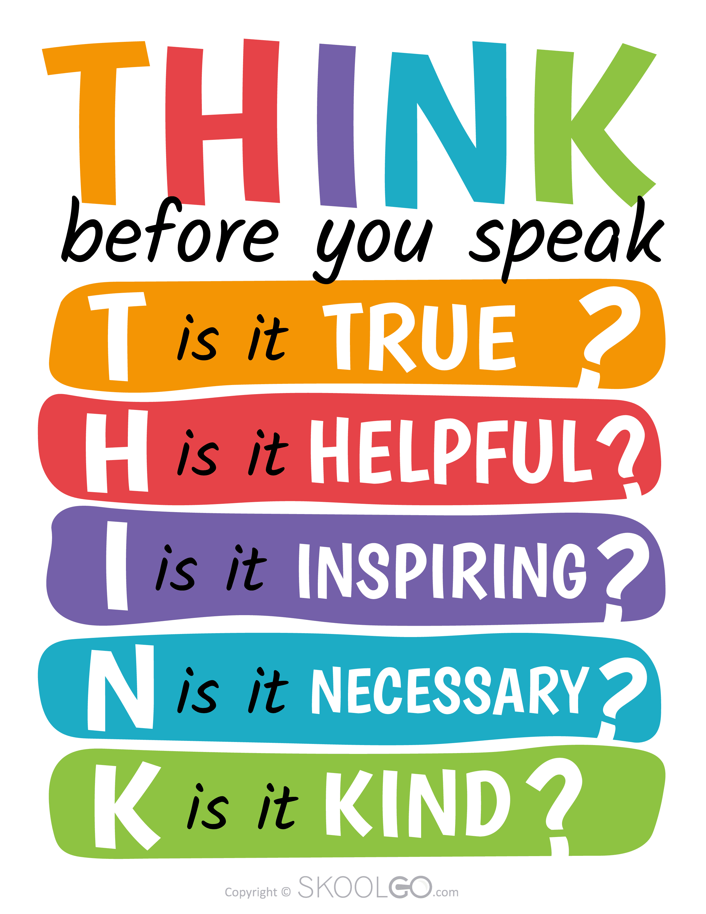
In our school, we actively promote THINK, to promote a culture which celebrates and tolerates differences and helps keep their peers safe both online and offline.

What is a prejudice related incident? Prejudice related incidents are one-off incidents relating to a protected characteristic, which may or may not be directed at an individual. They may or may not be carried out with the intention to harm or cause offence.

Bullying and Prejudice Related Incidents can take many forms including:
- Verbal – Name calling and ridicule such as racist or homophobic remarks.
- Visual – Graffiti, gestures, wearing racist insignia or showing pictures.
- Incitement – Spreading rumours or encouraging others to participate.
- Cyber – Using technology such as text messages, Facebook, Snapchat, Instagram or email.
- Segregation – Excluding, isolating, ignoring or avoiding an individual from the activities or social acceptance of their peer group.
- Physical – Hitting, pushing, unwanted touching, kicking or threatening with a weapon.
- Property – Theft or damage to personal property.

Our Commitment
As a Rights Respecting School Gold School, we are committed to creating a safe, inclusive environment where all children can learn free from anxiety and harm. Bullying and prejudice related incidents are a serious safeguarding issue, and we take all incidents seriously. As a result, in addition to this policy, we have an Anti-Bullying and Prejudice Related Incidents Policy, which supports DfE guidance, including ‘Preventing and Tackling Bullying’ (2017), and sets out our consistent approach to addressing bullying. Staff, pupils, and families are made aware of their roles in recognising and responding to bullying and prejudice related incidents. We help children develop empathy and conflict-resolution skills, promoting positive relationships and a respectful school culture.

Child-on-child abuse
Child-on-child abuse, children harming other children, is unacceptable and will be taken seriously; it will not be tolerated or passed off as ‘banter’, ‘just having a laugh’, ‘part of growing up’ or ‘boys being boys’. It is more likely that boys will be perpetrators of child-on-child abuse and girls victims, but allegations will be dealt with in the same manner, regardless of gender.

Child-on-child abuse can take many forms, including:
- physical abuse such as shaking, hitting, biting, kicking or hair pulling;
- bullying including cyberbullying, prejudice-based and discriminatory bullying;
- sexual violence and harassment such as rape and sexual assault or sexual comments and inappropriate sexual language, remarks or jokes;
- causing someone to engage in sexual activity without consent, such as forcing someone to strip, touch themselves sexually, or to engage in sexual activity with a third party;
- up skirting, which involves taking a picture under a person’s clothing without their knowledge for the purposes of sexual gratification or to cause humiliation, distress or alarm;
- consensual and non-consensual sharing of nude and semi-nude images and/or videos (also known as sexting or youth produced sexual imagery) including pressuring others to share sexual content;
- abuse in intimate personal relationships between peers (also known as teenage relationship abuse) - such as a pattern of actual or threatened acts of physical, sexual or emotional abuse;
- initiation/hazing – used to induct newcomers into sports team or school groups by subjecting them to potentially humiliating or abusing trials with the aim of creating a bond. Different gender issues can be prevalent when dealing with child on child abuse, for example girls being sexually touched/assaulted or boys being subject to initiation/hazing type violence.

Child-on-Child Sexual Violence and Sexual Harassment
At our school, we are fully committed to creating a safe, respectful, and nurturing environment for all pupils. If we receive any report of sexual violence or sexual harassment between pupils- whether it happens in person or online - we take it seriously and respond in line with our safeguarding duties, particularly as set out in Keeping Children Safe in Education (KCSIE), Part 5.
The designated safeguarding lead (or their deputy) will take the lead in responding to such incidents. Each situation will be considered individually and with care. We are committed to making sure every pupil feels safe, respected, and valued. This includes teaching pupils about healthy friendships, respectful behaviour, and how to speak up if something makes them feel uncomfortable or unsafe.
If a pupil ever reports sexual harassment or inappropriate behaviour from another pupil, whether it happens in school, outside school, or online, we take it very seriously. We follow national safeguarding guidance (Keeping Children Safe in Education) and make sure each case is handled with care and sensitivity.
Our safeguarding lead will make sure the right steps are taken, and we will support everyone involved. Every child who shares a concern will be listened to, taken seriously, and kept safe.
We do not tolerate any form of sexual harassment or inappropriate behaviour. We don’t excuse harmful behaviour as "just joking" or “part of growing up.” We believe all pupils have the right to feel safe and respected, and we expect everyone in our school to treat others with kindness and dignity.
If needed, we may give consequences in line with our behaviour policy, even while other professionals (such as the police or social services) may be involved. We also work closely with families and other services to make sure the right support is in place.
Our staff are trained to notice, challenge, and respond to inappropriate behaviour. We also use the Respectful School Communities guidance to help create a school culture where all pupils feel secure and know how to treat others well.
All staff are expected to challenge inappropriate language and behaviour between pupils. We use the Respectful School Communities toolkit to support us in building a culture where everyone understands what respectful relationships look like and where harmful behaviour is not accepted.
We do not excuse harmful or inappropriate language by calling it “banter” or treating it as just part of growing up. Instead, we teach and model kindness, respect, and responsibility in everything we do.
If a pupil behaves in a sexually inappropriate way, we will take steps to address it straight away- even if there are also investigations happening by the police or social care. Responding early helps prevent further harm or serious behaviour later on. Guidance from Part 5 of KCSIE helps us access the right support for any pupil involved.
It is very important that any pupil who reports sexual harassment or abuse feels believed, supported, and safe. This applies no matter how long ago the incident happened or whether it took place inside or outside of school, including online. Pupils will never be made to feel that they are causing trouble by speaking up, and their experience will never be minimised.
If an allegation is found to be deliberately untrue or made to cause harm, we will consider appropriate action under our behaviour policy.
As with all safeguarding concerns, our designated safeguarding lead will involve other professionals or services when needed to ensure the right support is in place for all pupils involved.
Investigating allegations
All allegations of child-on-child abuse will be recorded via CPOMS.
The Designated Safeguarding Lead (DSL) has oversight of these reports. We will go through the following process in dealing with allegations:

- Gather information - children and staff will be spoken with immediately to gather relevant information by a member of the pastoral team
- Decide on action - if it is believed that any child is at risk of significant harm, a referral will be made to children’s social care. The DSL will then work with children’s social care to decide on next steps, which may include contacting the Police. In other cases, we may follow this policy alongside the Child Protection and Safeguarding Policy.
- Inform parents - we will usually discuss concerns with the parents. However, our focus is the safety and wellbeing of the pupil and so if the school believes that notifying parents could increase the risk to a child or exacerbate the problem, advice will first be sought from children’s social care and/or the Police before parents are contacted.
- Recorded – all concerns, discussions and decisions made, and the reasons for those decisions will be recorded in writing (using CPOMs as far as possible). The record will include a clear and comprehensive summary of the concern, details of how the concern was followed up and resolved, and a note of the action taken, decisions reached and the outcome.

Where allegations of a sexual nature are made, the school will follow the statutory guidance set out in Part 5 of Keeping Children Safe in Education 2021.

Online Behaviour Incidents
At our school, we know that the way pupils behave online can have a real impact on how safe and happy everyone feels at school. When pupils treat each other unkindly online - whether during or outside of school hours - it can affect friendships, learning, and our whole school community.
We expect pupils to follow the same high standards of behaviour online as they do in person. This means treating others with kindness, respect, and dignity at all times, no matter the platform or device being used. Filtering and monitoring identify inappropriate use of technology in school.
Online behaviour such as bullying, unkind messages, inappropriate language, or sharing of inappropriate images or videos, including nude or semi-nude content, will be taken seriously and dealt with using the same principles as face-to-face incidents. These incidents may also involve safeguarding concerns and will be managed in line with our Child Protection Policy, Online Safety Policy and Keeping Children Safe in Education (KCSIE). If needed, our designated safeguarding lead (or deputy) will advise on the best response.
When reports involve nude or semi-nude images or videos, staff must report the concern directly to the designated safeguarding lead, who will manage the situation following the advice in KCSIE and the guidance from the UK Council for Internet Safety: Sharing nudes and semi-nudes: advice for education settings working with children and young people.
Most online incidents happen outside school, but if they affect how pupils feel or behave in school, we will take action. If online behaviour threatens another pupil, disrupts learning, or affects the school’s reputation, we may apply sanctions, even if the behaviour happened at home, especially if the pupil is identifiable as a member of our school.
While parents are primarily responsible for monitoring their child's online activity outside of school, we will always work in partnership with families to address any concerns and support pupils to behave safely and responsibly online.
Physical Attacks on Adults
We take incidents of violence toward staff very seriously. We understand that staff are the adults in the situation and can use a ‘common sense’ approach to keep themselves and the child safe. Staff can use ‘reasonable measures’ to protect themselves and should call for additional support. Staff who protect themselves will have the full support of the Senior Leadership Team, as long as their actions are in line with our policy and do not use excessive force. All staff must report incidents of pupil violence toward themselves to the Headteacher (or Deputy Headteacher in their absence). These incidents can cause distress for the adults involved, therefore all staff are entitled to take some reset time away from the classroom to recover.

Suspected Criminal Behaviour
At our school, we take any suspicion of criminal behaviour seriously and ensure that the safety and well-being of our pupils is always our top priority. If a member of staff or the headteacher suspects that criminal behaviour may have occurred, we will carefully assess the situation to understand the facts. This assessment will be based on gathering relevant information and documenting everything thoroughly.
If we determine that the incident may be a criminal matter, we will report it to the police and take care not to interfere with any police investigations. However, the school can still continue to investigate the matter and apply any necessary consequences, as long as this does not conflict with the police's actions.
In many cases, when we report to the police, we will also report the incident to local children’s social care to ensure that all relevant support is in place. The designated safeguarding lead (or deputy) will usually take the lead on this process, as outlined in Keeping Children Safe in Education (KCSIE).
We understand that incidents involving child-on-child sexual violence and abuse are particularly sensitive, and we follow the guidance in Part 5 of KCSIE to ensure that we handle such matters with the utmost care and respect for all those involved.

Bullying and Prejudiced Related Incidents
Prejudice-related incidents, including those based on race, religion, gender, disability, sexual orientation, or other protected characteristics, are taken extremely seriously and are not tolerated at our school. While this Behaviour Policy outlines our overall approach to promoting positive behaviour and responding to misconduct, specific guidance on identifying, recording, and responding to prejudice-related incidents is provided in our Anti-Bullying and Prejudice-Related Incidents Policy. This dedicated policy ensures that all such incidents are addressed promptly, consistently, and in line with statutory requirements, promoting a safe and inclusive environment for all pupils.
Mobile Phones
At our school, we are committed to providing a focused, safe, and inclusive learning environment for all pupils. To support this, we have a clear policy that creates a mobile phone-free school day. This means that pupils are not allowed to use mobile phones or other smart devices (such as smart watches with similar functionality) at any time during the school day, including lessons, breaktimes, lunchtimes, and the time between lessons.
Our approach follows the Department for Education’s guidance on mobile phones in schools, and is designed to reduce distractions, support positive behaviour, and help all pupils feel safe and included.
We ask all pupils and families to follow these simple rules:
- Pupils should not bring mobile phones or smart devices to school unless it has been agreed in advance with a member of staff (for example, for safety reasons when walking to or from school).
- If a pupil does bring a mobile phone, it must be switched off and handed in to staff at the start of the day. It will be returned at the end of the school day.
- Any use of mobile phones or smart devices during the school day without permission will lead to consequences, in line with our behaviour policy.
- We make sure these rules are clear and easy for pupils to understand, and we support all staff in applying them fairly and consistently.

We also recognise that some pupils may need reasonable adjustments—for example, pupils with medical conditions or disabilities. Where appropriate, we will work with parents and carers to agree individual adaptations. Each case will be considered carefully, based on the needs of the pupil.
By working together to keep mobile phones and smart devices out of the school day, we help our pupils stay engaged, respectful, and ready to learn. Our Online Safety Policy includes more details.

Appendix 1: Behaviour Summary Table

 | Behaviour Summary Table
 | Category |  | Examples (not an exhaustive list) |  | Response |  | Possible Sanction
 | Isolated or rare low-level disruption |  | Not following the behaviour charter, distracting others from learning, shouting out, talking, not focused on work, not following instructions |  | - Reminder: of the expectations in a positive way which includes noticing and a quiet conversation to refocus  - Warning: use of the behaviour system. A quiet conversation (sanction in private) to indicate that a change is needed. A reminder of the behaviour, impact and sanction. This will be scripted “I have set an expectation of not shouting out and you have just shouted out. This is a warning. If this happens again then I will give you a sad face”  - Time / support: Time offered for pupil to reset and offer of support to reach expectation set – this could include a move of chair or proximity to an adult.  - Restore: Noticing that behaviour has improved and celebrate successes. |  | - Warning or 1 sad face.  - An immediate sad face will be issued to any child using inappropriate language and receive a sanction of a loss of playtime.
 | Persistent low-level disruption |  | Repeated or regular behaviours that contravene the behaviour charter |  | Repeat of above.  - Further support and guidance offered in the spirit of positive praise, restoration and giving a chance to do the right thing.  - If further sad faces are issued then further implications of behaviour policy are enforced.  - Where golden time is missed this is recorded on CPOMS.  - Reflection sheets completed as part of restorative conversation (appendix) |  | 2nd (or 3rd in KS1) sad face which will result in reduced or missed playtimes, loss of Golden time (reward free time)  Conversation with a Senior Leader  Note in planner for parents.  Phone call home  Parent meeting
Unacceptable / extreme behaviours |  | Child on child abuse, violence towards staff, extreme verbal abuse, vandalism of school property, bullying, defiance, absconding  Bullying (See anti-bullying policy)  Racist/homophobic behaviour (criteria sourced from Dudley LA Standard Operating Procedure). The definition of a racist incident is “any incident which is perceived to be racist by the victim or any other person”. include:  Derogatory name calling, insults, racist jokes and language  Racist graffiti  Incitement of others to behave in a racist way (which could be perceived to be radicalisation)  Racist comments in the course of discussions in formal and informal settings  Ridicule of an individual for cultural or religious differences e.g. food, music  Refusal to co-operate with others because of race or ethnic origins  Repeated physical assault/ aggression (any violent incident should be recorded)  Repeated bad language  Damage to property  Stealing  Threatening behaviour towards an adult  Any behaviours that constitute a health and safety risk to themselves or others |  | - Request of support from another member of staff (adult swap)  - Further assistance from a senior leader (Assistant Headteacher) who will:  - Ensure safety of pupils and staff  - Investigate the incident  - Communicate next steps to staff regarding next steps  - Issue appropriate sanction / follow up reflection  - Communicate with parents including any victim families  - Update CPOMS and actions  - Check in with teacher / class / pupil for follow ups  - Ongoing monitoring of pupils / class  - Ongoing parental communication |  | - Time away from class / peers as appropriate  - Playtime reduced  - Loss of Golden time  - Internal suspension from unstructured time  - Direct work if appropriate to address needs  - Suspension  - Exploring alternative provision to meet needs  - Exclusion

Appendix 2: Celebrating Behaviour In Our School
The school believes it is important to encourage good conduct throughout school by celebrating and recognising ‘over and above’ behaviour. The behaviour policy focuses on positive behaviour as well as negative. We aim to promote good behaviour in school by giving children who behave well, a high profile in school. Over and above behaviour and effort are encouraged and rewarded, publicised and used as a model for others to follow and in order to prevent bullying. Examples of over and above behaviour will be highlighted and acknowledged by a well-structured system of over and above recognition that ensures consistency across the school. We use house points in the classroom to support the behaviour policy. Each teacher may also have their own individual class recognition systems, strategies and incentives to motivate and encourage each unique group of pupils.

Positive recognition helps to identify positive aspects of each child’s behaviour: they make them aware of their abilities and qualities and they help to build self-esteem.

Recognition of over and above behaviour
EYFS | We value children’s efforts, interests and purposes as instrumental to successful learning. We are careful with over and above recognition and praise, always being specific. We give feedback on the process rather than rely on external rewards. We support children’s Personal, Social and Emotional Development (PSED) through a rich curriculum where children have regular opportunities with their key person, small group and in circle time to learn how to manage their feelings and become aware of how their own actions affect others.  We celebrate positive behaviour through:  - House points  - Stickers  - Smile boards  - Star of the day  - Star of the week  - Verbal in the moment praise with specific feedback – e.g “I love how you are lining up! You are standing sensibly and ready to move – well done! Great job!” or “Thank you for sitting so brilliantly. You are looking at me and ready to listen – this means you are ready to learn! Fantastic!”  - Other class based systems such as raffle tickets, secret pupil, noticing etc
Key Stage 1 and 2 | Each class may have its own system to reward good behaviour and work.  Over and above recognition may include:  - A behaviour Champion Award (ABC) – at least termly award for consistently excellent behaviour at all times (1 pupil per class)  - Specific Praise – when children reach or surpass the adults’ expectations  - Written comments on work  - Stickers / stamps to stick on work or to wear  - Recognition in front of the group or class, praise or whole-school assembly  - Certificates to recognise work or behaviour  - Achievement awards/certificates/badges for sport, swimming and other achievements  - Telling parents (verbally or written)  - Good news messages  - Smile boards  - Good behaviour written in pupil planners  - House points  - Small over and above recognition such as a 5 minute’s extra play  - Golden time  - Worker of the week  - Star of the day  - House points are awarded for the academic achievements, upholding our school rules, behaviour charter and upholding our school values. These are collated each week and the winning house announced in the achiever assembly and displayed in the school hall.  - Extra golden time/ play time for class over and above recognition

Rewarding whole classes when working towards helping a child with significant disruptive behaviour
In some extreme incidents, the inappropriate behaviour of a child may have a detrimental effect on a whole class. It is really important that the class’s encouragement and support is rewarded i.e. when the disruptive child has a positive lesson/day/week etc. the rest of the children are praised and rewarded for their help. This can be done in a number of ways: Whole-class reward - by asking Headteacher, Assistant Headteacher or Assistant Headteachers to come to congratulate the class, hand out stickers etc.
Appendix 3: Responding To Behaviour In Our School

Reception
Strategies for ‘teaching’ particular behaviours
Conflict resolution | We adopt the High-Scope / Emotion Coaching approach to conflict resolution:
Conflict resolution | Approach calmly, stopping any hurtful verbal and/or physical actions - place yourself between the children, on their level. Use a calm voice and gentle touch. Remain neutral rather than take sides. Set the limit and explain why this cannot continue e.g. “It’s not okay to (label the behaviour). I am afraid someone will get hurt/they have been hurt.”
Conflict resolution | Acknowledge children’s feelings - “You look really upset.” Let children know you need to hold any object in question.
Conflict resolution | Gather information - “What’s the problem?”
Conflict resolution | Restate the problem - “So the problem is…”
Conflict resolution | Ask for ideas for solutions and choose one together - “What can we do to solve this problem?” Encourage children to think of a solution.
Conflict resolution | Be prepared to give follow-up support - “You solved the problem!” Stay near the children.
Swearing | - Set the limit saying “We use kind words.”  - Explore understanding of words and educate whether a word is appropriate or not (without defining).  - Parents are always contacted about inappropriate language.  - Repeated inappropriate language will be sanctioned.
Destructive behaviour | - Stop the destructive behaviour.  - Use calming / grounding strategies if needed.  - Explain why they can’t continue. Talk about their feelings, what the problem is and how to solve it.  - The child will then be asked to tidy up and/or repair items if possible.  - Repeated destructive behaviour will result in risk assessment and possible behaviour plan in communication with SENDco and parents.
Extreme physical aggression or persistent aggressive or disruptive behaviour | On occasions such as extreme physical aggression or persistent aggressive or disruptive behaviour, the Assistant Headteacher and/or Headteacher will be consulted. The SENCo may also become involved. In these cases, a child’s parents will be contacted.
Over time, if a child is showing extreme behaviours which are not able to be managed within the school’s behaviour policy and it looks likely that the child is a risk of suspension or permanent exclusion, Dudley Inclusive Pathways guidance will be followed (appendix 1 and 2).
If a child continues to demonstrate ‘challenging’ behaviour we will continue to use the above strategies in addition to using the visual behaviour chart away from others as we reprimand in private to respect the child’s dignity and feelings of shame in front of others.
Second time: | Show the child the yellow face and indicate which rule that has been broken and what they need to do next.
Third time: | Show the child the red face and indicate which rule that has been broken and what they need to do next. Write in planner.
Persistent unacceptable behaviour | Spend time with the Early Years Leader in another classroom for 5-10 minutes. If the child is in the Early Years Leader’s class, the child will spend 5-10 minutes in another EYFS classroom.

Years 1-2 Sanctions including loss of Golden Time
Sad face sanction works in conjunction with golden time and will be communicated to parents through their child’s pupil planner.
1st sad face ☹ | Written in planner by teacher to communicate to parents. The teacher will have a conversation with the child about their behaviour and consider support strategies for their behaviour to improve. The comment will be linked to the rules.
2nd sad face ☹☹ | Further disruption: Written in planner by teacher to communicate to parents.  The teacher will have a restorative conversation the child about their behaviour and consider support strategies for their behaviour to improve. The child will reflect and repair in a range of ways such as completing missed work at home, doing a job for the member of staff, writing a letter/ drawing a picture of apology to the person affected.  The child will miss their playtime.
3rd sad face given ☹☹☹ | Continued disruption: Year 1-2. No golden time that week. An adult will write in planner that golden time has been missed. The teacher will have a conversation with the parents and the child about their behaviour and consider support strategies for their behaviour to improve. The child will reflect and repair in a range of ways such as completing missed work at home, doing a job for the member of staff, writing a letter/ drawing a picture of apology to the person affected.
4th sad face ☹☹☹☹ | The child will miss 5 break times and meet with the Deputy Headteacher. A note will be made in the planner and parents will be contacted.  Further restoration work will be carried out with the child with DHT and/ or teacher.
5th sad face ☹☹☹☹☹ | The child will see the Headteacher about their behaviour and their parents will be invited in. The child may also be given a behaviour diary overseen by the SENCo and the SENCo may organise pastoral support for the child. Sanctions will be decided on an individual basis. The school may decide to send the child to another school within our Multi Academy Trust. This placement will be for a fixed period of time, ascertained by the Head teacher and unique to individual cases (see section 7).
Severe disruption: ** | Sent straight to the Deputy Headteacher or Headteacher. The incident will be recorded in the child’s planner and parents will be contacted and sanctions will be determined based on the disruption.
(** see section which outlines what constitutes “Severe Behaviour”)

If a child misses their golden time 3 times, within a half term, then a behaviour diary may be set up for the child.
Three sad faces and loss of lunchtime play will be issued to any child using physical aggression towards another child (including retaliation). This will be deemed to be child on child abuse as set out in Keeping Children Safe in Education 2024. Golden time will also be lost. Parents of both children will be contacted. During the time when a child misses playtime, work will be carried out with the child, and the child will think about how they can repair the relationship with the child they were physically aggressive towards. This could be done in conversation with the class teacher as described above or by using ‘back-chaining’ (appendix 4) or a reflective think sheet (appendix 5). Reflective think sheets will be kept by the class teacher and monitored by the senior leadership team.
Over time, if a child is showing extreme behaviours which are not able to be managed within the school’s behaviour policy and it looks likely that the child is a risk of suspension or permanent exclusion, Dudley Inclusive Pathways guidance will be followed (appendix 1 and 2).
In instances of bullying, staff will follow our anti-bullying policy. In addition to a suitable sanction being issued, both the victim and the perpetrator of bullying will receive support so that bullying does not happen again. Parents of both the victim and perpetrator will be communicated with.

Years 3-6 Sanctions including loss of Golden Time

First time a pupil breaks a rule: warning is given before every sad face
1st sad face ☹ | Written in planner by teacher to communicate to parents. The comment will be linked to the rules. The teacher will have a restorative conversation the child about their behaviour and consider support strategies for their behaviour to improve.  The child will miss their playtime
2nd sad face ☹☹ | Continued disruption: Year 3-6. No golden time that week. An adult will write in planner that golden time has been missed. The teacher will have a conversation with the parents and the child about their behaviour and consider support strategies for their behaviour to improve. The child will reflect and repair in a range of ways such as completing missed work at home, doing a job for the member of staff, writing a letter/ drawing a picture of apology to the person affected.
3rd sad face given ☹☹☹ | The child will miss 5 playtimes. The child will meet with the Assistant Headteacher, and a note will be made in their planner and  parents will be contacted. Further restoration work will be carried out with the child with AHT and/ or class teacher.
4th sad face ☹☹☹☹ | The child will see the Deputy Headteacher about their behaviour and their parents will be invited in. The child may also be given a behaviour diary overseen by the SENCo and the SENCo may organise pastoral support for the child. Sanctions will be decided on an individual basis Sanctions will be decided on an individual basis. The school may decide to send the child to another school within our Multi Academy Trust. This placement will be for fixed period of time, ascertained by the Headteacher and unique to individual cases (see section 7).
5th sad face ☹☹☹☹☹ | The child will miss 5 playtimes. The child will meet with the Assistant Headteacher, and a note will be made in their planner and  parents will be contacted. Further restoration work will be carried out with the child with AHT and/ or class teacher.
Severe disruption: ** | Sent straight to the Deputy Headteacher. The incident  will be recorded in the child’s planner and parents will be contacted and  sanctions will be determined based on the disruption.
(** see section which outlines what constitutes “Severe Behaviour”)

If a child misses their golden time 3 times, within a half term, then a behaviour diary may be set up for the child.
The class teacher will keep a record of both to enable them to track patterns of negative behaviour.
Two sad faces will be issued to any child using physical aggression (including retaliation). This is known as child on child abuse in Keeping Children Safe in Education 2024. This will mean a loss of golden time. In addition to this, a loss of breaktime and lunchtime play will also be issued. Parents of both children will be contacted. During the time when a child misses playtime, work will be carried out with the child, and the child will think about how they can repair the relationship with the child they were physically aggressive towards. This could be done using ‘back-chaining’ (appendix 4) or a reflective think sheet (appendix 5). Reflective think sheets will be kept by the class teacher and monitored by the senior leadership team.
Over time, if a child is showing extreme behaviours which are not able to be managed within the school’s behaviour policy and it looks likely that the child is a risk of suspension or permanent exclusion, Dudley Inclusive Pathways guidance will be followed (appendix 1 and 2).
In instances of bullying, staff will follow our anti-bullying policy. In addition to a suitable sanction being issued, both the victim and the perpetrator of bullying will receive support so that bullying does not happen again. Parents of both the victim and perpetrator will be communicated with.
The school reserves the right not to refund costs where a pupil is withdrawn from an activity by the school on the basis of a pupil's breach of the school's behaviour policy.

Appendix 4: Lunchtime Behaviour Summary Table
Lunchtime Behaviour

Our Behaviour Charter and rules will be visible on the playground and should be referred to by all staff when dealing with positive or negative behaviour on the playground.

Foundation Stage, Key Stage 1 and 2 playtimes, over and above recognition and sanctions
Children modelling good citizenship e.g. helping, caring, sharing and living up to behaviour expectations are rewarded with specific praise, stickers and house points. At playtime if a child is disruptive, the member of staff on duty may ask them walk with them for a few minutes or sit on the bench as a ‘time out’ sanction.

Year 4 and 6 playground leaders work under the direction Assistant Head teachers and key staff adults leading this initiative. They work with children on the playground, helping children to play together, and hence develop social skills; at the same time reinforcing the expectation for good behaviour at lunchtime. They also take on the role of Anti-Bullying Ambassadors. In year 5 children, can become a buddy working in the playground, they are given the opportunity to solve problems under adult supervision.

Note: Dinner Supervisors play a key part in Health and Safety and need staff to share on a regular basis the playground rules:
- To keep safe, children should not run through the trees.
- To keep safe, children should not swing or climb on bars or trees.
- To keep safe, children should not play on or near the fire escape through the trees.
- The only reason to be indoors is to use the toilet or the water fountain or if they need first aid administered.

Good behaviour | House Points, specific praise
Inappropriate behaviour | Verbal warning (Yellow Card)
Continued inappropriate behaviour | 5 minutes time out (Red Card)  Teacher informed via a red card incident form.  Some circumstances may result in a member of the Well-being Team becoming involved to support the child to reflect on behaviour and a short intervention may be put in place. Parents will be informed if a child reaches 5 red cards. Teacher will work with the child / parents to put strategies in place to support the child.
Physical aggression/ assault towards another child. Child on child abuse. | Three sad faces will be issued to any child using physical aggression (including retaliation). This will mean a loss of golden time. In addition to this, a loss of breaktime and lunchtime play will also be issued. Dinner Supervisors will complete an investigation form which will be entered on CPOMS by class teacher. Parents of both children will be contacted. During the time when a child misses playtime, work will be carried out with the child, and the child will think about how they can repair the relationship with the child they were physically aggressive towards. This could be done using ‘back-chaining’ (appendix 4) or a reflective think sheet (appendix 5). Reflective think sheets will be kept by the class teacher and monitored by the senior leadership team.
Further inappropriate behaviour | Walk with the dinner supervisor; teacher advised of behaviour. Information added to red card.  A teacher will speak with the child as above. Parents will be informed via the planner and a call home.

Key Stage 2 Lunchtime over and above recognition and sanctions from dinner supervisors
Good behaviour | House Points, specific praise
Inappropriate behaviour | Verbal warning (Yellow Card)
Continued inappropriate behaviour | 10 minutes walking with staff on duty (Red Card)  Teacher informed via a red card incident form.  Some circumstances may result in a member of the Well-being Team becoming involved to support the child to reflect on behaviour and a short intervention may be put in place. . Parents will be informed if a child reaches 5 red cards. Teacher will work with the child / parents to put strategies in place to support the child.
Physical aggression/ assault towards another child. Child on child abuse. | Two sad faces will be issued to any child using physical aggression (including retaliation). This will mean a loss of golden time. In addition to this, a loss of breaktime and lunchtime play will also be issued. Dinner Supervisors will complete an investigation form which will be entered on CPOMS by class teacher. Parents of both children will be contacted. During the time when a child misses playtime, work will be carried out with the child, and the child will think about how they can repair the relationship with the child they were physically aggressive towards. This could be done using ‘back-chaining’ (appendix 4) or a reflective think sheet (appendix 5). Reflective think sheets will be kept by the class teacher and monitored by the senior leadership team.
Further inappropriate behaviour | Teacher informed on an incident form  15 minutes loss of social time with a teacher for the next break time/lunchtime. A teacher will speak with the child as above. Parents will be informed via the planner and a call home.

Lunchtime Behaviour Incident Form
Behaviour incident Form
(Physical assault)
- First Aid administered where appropriate?
- Both teachers informed? (Form given to Perpetrator’s teacher)

Perpetrator(s)…………………………………….. Class………………………

Victim (s) ………………………………………. Class………………………….

What happened? (from both Perpetrator / Victims perspective)
…………………………………………………………………………………….………….
………………………………………………………………………………………….…….
…………………………………………………………………………………….………….
………………………………………………………………………………………….…….
……………………………………………………………………………………………….
……………………………………………………………………………………………….
………………………………………………………………………..…………………….
……………………………………………………………………………………………….

- Witness accounts? (KS2 Children to write it down)
Name of witness (es) ……………………………………. Class …………………… ……………………………………………………………………………………………….
……………………………………………………………………………………………….
………………………………………………………….……………………………….

Recommendation to teacher
……………………………………………………………………………………………….
……………………………………………………………………………………………….
Name of staff investigating: …………………….…………………………..
Witness statement
Name: ………………………………………. Class………………………….

What happened? Why do you think it happened?
…………………………………………………………………………………….
…………………………………………………………………………………….
…………………………………………………………………………………….
…………………………………………………………………………………….
…………………………………………………………………………………….
…………………………………………………………………………………….
…………………………………………………………………………………….
…………………………………………………………………………………….

Appendix 5: Investigating an incident

Guideline for Behaviour Incident Investigation
This guideline provides a clear, fair, and consistent process for investigating pupil behaviour. Its aim is to help staff understand incidents fully, support positive outcomes, and maintain a safe and respectful school environment. Investigations will be led by a member of the senior leader team and should be timely to avoid unnecessary stress, as well as ensure accuracy of information.
Staff should follow the principles of approaching behaviour concerns with empathy and a focus on development and ensure fairness and impartiality throughout the investigation.
1. Initial Response
- Ensure Safety: Immediately address any safety concerns for pupils and staff.
- Stay Calm: Approach the situation calmly and professionally.
- Gather Basic Information: Note the time, place, and those involved or witnessed the behaviour.

2. Collecting Information (including back chaining)
- Speak with the Pupil(s) Involved:
- Ask open-ended questions to understand their perspective.
- Use a calm and non-confrontational tone.
- Allow the pupil to explain without interruption.

3. Interview Witnesses
- Speak privately to any witnesses, including other pupils and staff.
- Take note of differing accounts without making immediate judgments.

4. Review Evidence:
- Check for any relevant evidence such as CCTV footage, written reports, or digital communications.
5. Documentation
Record All Findings:
- Document the pupil’s account, witness statements, and any physical or digital evidence.
- Include dates, times, and descriptions of incidents.
- Maintain Confidentiality: Share information only with relevant staff and adhere to school policies on data protection.

6. Assessment
- Consider Context:
- Consider the pupil’s background, previous behaviour records, and any external factors.

7. Identify Patterns
- Look for recurring issues or triggers to better understand the behaviour.
- Apply School Policies:
- Reference the school’s behaviour policy and code of conduct to evaluate the incident fairly.

8. Decision Making
Determine Appropriate Action:
- Decide on necessary interventions, support, or disciplinary measures based on the findings.
- Aim for restorative practices, when possible, to support positive change.

Involve Parents/Guardians:
- Inform parents or guardians when appropriate and involve them in follow-up actions.
- Plan Follow-up: Set a date to review the pupil’s progress or the effectiveness of interventions.

9. Communication
- Report to Relevant Staff: Share the outcome and any required actions with teaching staff and pastoral teams.
- Provide Feedback to the Pupil: Communicate decisions and support clearly and constructively to the pupil involved.

10. Review and Reflection
- Monitor Behaviour: Keep track of the pupil’s behaviour after the investigation to ensure improvement.
- Reflect on Procedures: Evaluate the context of the incident and make any required adjustments.

Back chaining flow chart and guidance

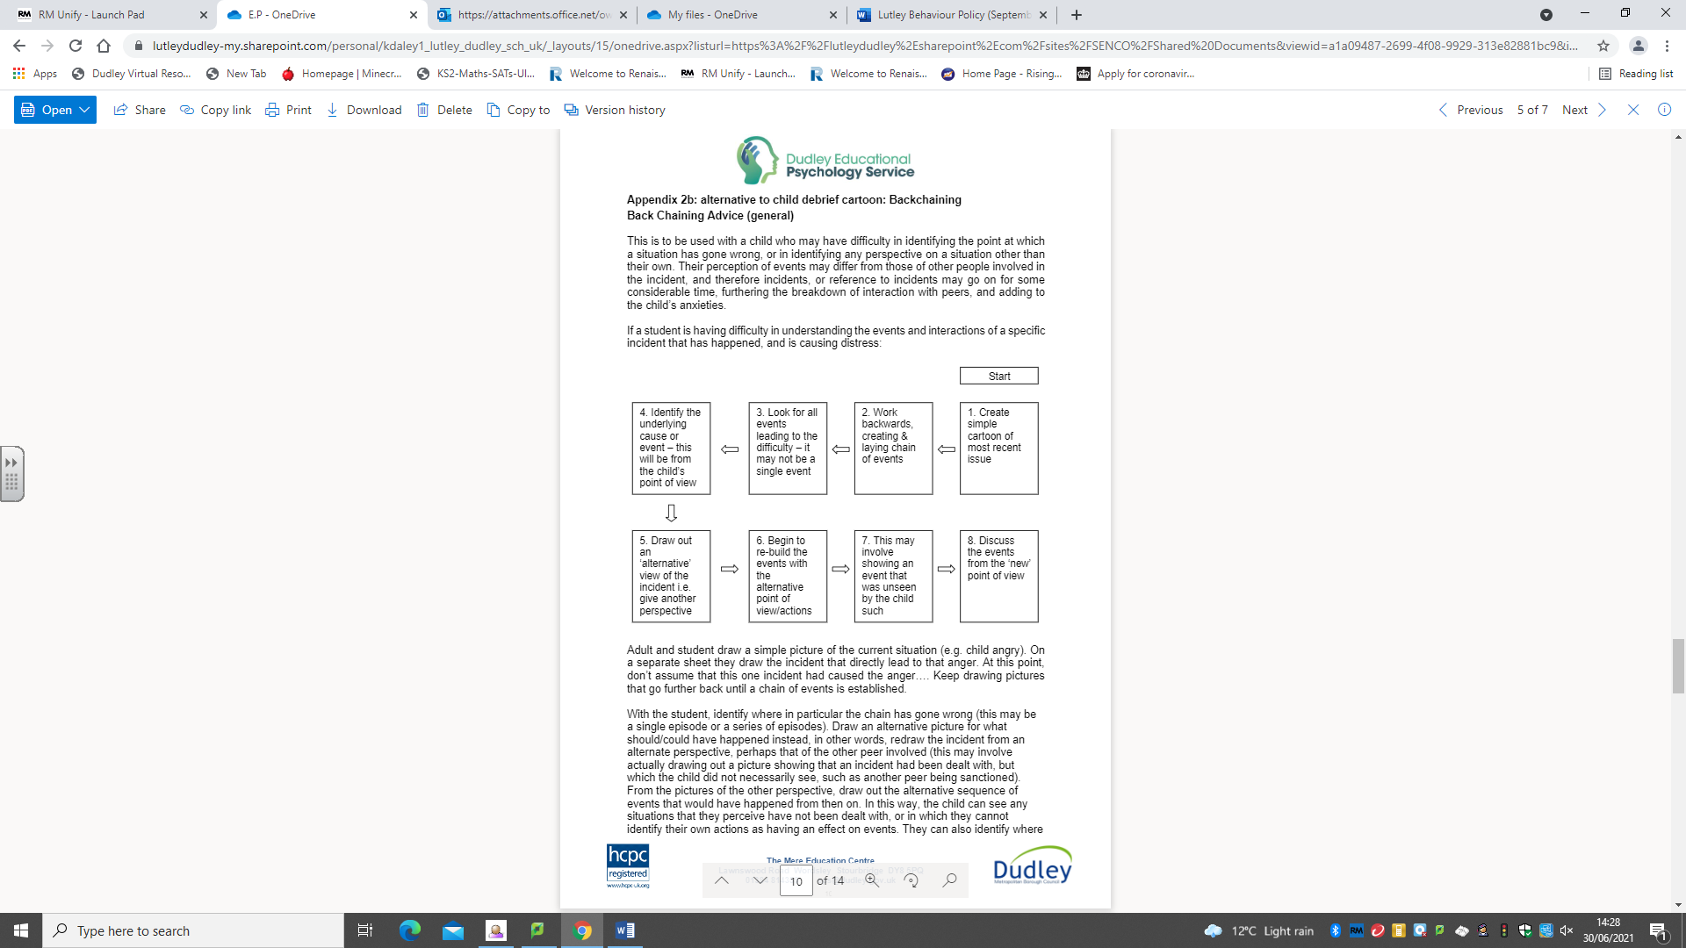

This is to be used with a child who may have difficulty in identifying the point at which a situation has gone wrong, or in identifying any perspective on a situation other than their own. Their perception of events may differ from those of other people involved in the incident, and therefore incidents, or reference to incidents may go on for some considerable time, furthering the breakdown of interaction with peers, and adding to the child’s anxieties. If a student is having difficulty in understanding the events and interactions of a specific incident that has happened, and is causing distress use the back-chaining diagram above to support the child to explore the incident further.

Adult and student draw a simple picture of the current situation (e.g. child angry). On a separate sheet they draw the incident that directly lead to that anger. At this point, don’t assume that this one incident had caused the anger.... Keep drawing pictures that go further back until a chain of events is established.

- With the student, identify where in particular the chain has gone wrong (this may be a single episode or a series of episodes).
- Draw an alternative picture for what should/could have happened instead, in other words, redraw the incident from an alternate perspective, perhaps that of the other peer involved (this may involve actually drawing out a picture showing that an incident had been dealt with, but which the child did not necessarily see, such as another peer being sanctioned).
- From the pictures of the other perspective, draw out the alternative sequence of events that would have happened from then on. In this way, the child can see any situations that they perceive have not been dealt with, or in which they cannot identify their own actions as having an effect on events. They can also identify where a specific event could have been dealt with differently, and that a different course of events would have resulted.
- Keep the back chain (stick in a book as necessary), as it not only shows that an incident has been dealt with, but will also serve as a record of any incidents which are recurring and may need further intervention through strategies such as Social Stories.
- If necessary, keep the ‘alternate’ (modelled) outcome for future reference and file the back-chain in a ‘finished’ box.

Behaviour Incident Investigation Record
Date: | Location: |  | Time:
Pupil Name(s): |  | Class:
Type of behaviour (tick all that apply):  O Disruptive in class  O Physical aggression  O Verbal abuse  O Defiance  O Property damage  O Unsafe behaviour  O Bullying  O Other: __________________________ |  | Details of the Incident:
Summary of pupil(s) account

Summary of witness account(s)

Follow-Up Actions / Next Steps
O Parent meeting arranged
O Behaviour support plan initiated
O Restorative conversation scheduled
O Referral to SEN / pastoral support
O Monitoring behaviour chart
O Sanction
O Other:_______________________
Parent/Carer Acknowledgement  O Phone call made  O Letter sent home  O In-person meeting held |  | Parent/Carer feedback:

Appendix 6: 30 Second Script/Restorative Follow Up

30 second intervention:
- Gentle approach, personal, non-threatening, side on, eye level or lower;
- State the behaviour observed and which rule it contravenes;
- Tell the learner the consequence, refer to previous good behaviour as model;
- Walk away from the learner, allow them time to decide what to do next. If there are comments, note them down to follow up later;

30 second script:
- I noticed you are...
- It was the rule about...
- You have chosen to...
- Do you remember last week when you….
- That is who I need to see today...
- Thank you for listening.

Reparation Meeting
- A reparation meeting with the teacher and pupil should take no longer than 5 minutes and cannot be delegated to a colleague.
- It should be a genuine conversation that re-chalks the lines of acceptable behaviour and repairs damage.
- The meeting is to discuss the poor behaviour or incident: not the child’s character. The discussion is structured to address what happened, reinforce expectations and reset behaviours for the next lesson.
- Reparation will give a platform to build relationships that change and improve behaviour for the long term.

A good reparation meeting features the use of the following questions stems

Choose from:
- What happened?
- What have you thought since?
- How did this make people feel?
- Who has been affected?
- How have they been affected?
• What should we do to put things right?
• How can we do things differently in the future?

If pupils do not open up:
- Ok, imagine if there were…
- 1-10 how angry were you?
- I can see that you aren’t quite ready to talk…

Behaviour follow up is everything!
Appendix 7: Emotion Coaching
Emotion coaching enables children and young people to manage their own behaviour through helping them to understand the different emotions they experience,
why they occur, and how to handle them. Staff use a practical three-step approach to dealing with behaviour in the moment:
- Step 1 - Recognising, empathising, validating the feelings and labelling them
- Step 2 - Setting limits on behaviour
- Step 3 - Problem-solving with the child or young person

Staff will empathise with pupils’ feelings before engaging in discussion with pupils about behaviour, next steps or sanctions (where appropriate). This approach preserves the dignity of our pupils and enable staff to effectively deal with high emotional behaviour calmly. Staff are trained in this approach.
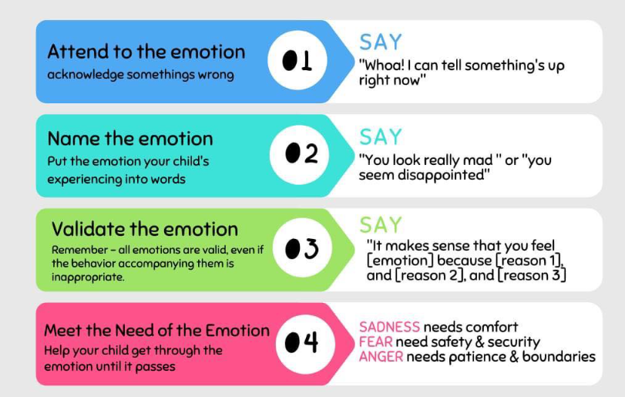

Appendix 8: Zones of regulation

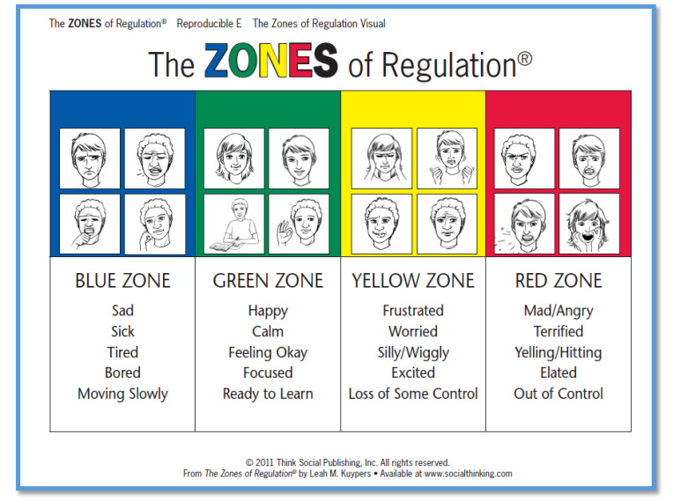
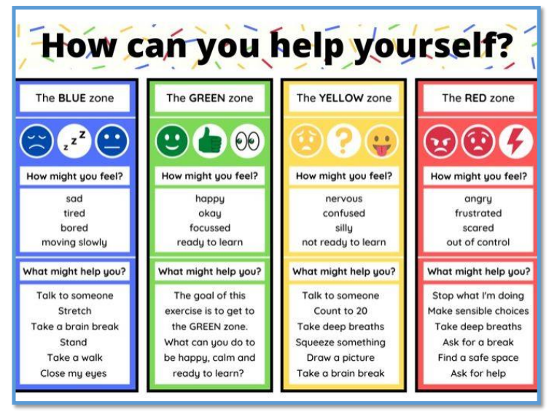

Appendix 9: Emotion Scaling Tool / Incredible 5-Point Scale
What is the Incredible 5-Point Scale?
The Incredible 5 Point Scale is a visual tool used to assist children in becoming aware of their emotions, such as anger or sadness, and the stage or level of the emotion. Using the scale, the child rates their emotions. The scale consists of 5 points, with each point/number representing a different level of e.g., volume or anger. Each number is given a different colour. In this way, the scale acts as a visual representation of the child’s feelings or actions. This then allows the child to (a) provide information to the adult about how they are feeling, (b) become more effective in managing their thinking process, and (c) implement the desired behaviour as a proactive approach. Giving a number instead of trying to describe or name an emotion helps children think efficiently to make good decisions in a variety of situations.
Who can Benefit from Emotions Charts?
Some children find it difficult to identify, label or express feelings, and this is when an emotions chart can be a very useful tool. All children can benefit from the help the visual clues emotion charts provide, but particularly those children that:
- do not communicate verbally
- have difficulties identifying other people’s emotions or their own
- have difficulties expressing feeling

How to Use the Scale
The first step in using the scale is to identify problem areas for the child.
For example, problems involving changes in routine, playing with peers, or following rules at work. The next step is to break the problem area into 5 parts clearly illustrating the degrees of the situation and putting this information onto a visual scale. See the example below:
- 5 = This could make me lose control
- 4 = This can upset me
- 3 = This can make me nervous
- 2 = This sometimes bothers me
- 1 = This never bothers me. *

Discuss the images with your child. Label and describe the feelings in each image.
What does each of them represent? How do I look and feel when I am at that level?
- Emoticon with a big smile: It represents happiness. I know I’m feeling great because I laugh and smile.
- Emoticon with a neutral face: It tells me I’m still doing ok. Not as great as before, but still ok.
- Emoticon with an something: It tells me something annoying is happening. It doesn´t feel good. I am starting to get angry. I frown. I don´t feel like smiling anymore.
- Emoticon with a very angry face: I´m feeling angry when I am like that. I may shout. I may also say things that are not nice.
- Emoticon with the angriest face: I´m out of control. I´m mad. I scream. Sometimes I hurt myself or others. I spit. I throw toys. I may destroy things.
Decide with your child what will be the “anger action plan” The strength of this tool is that it provides you with an opportunity to work on developing coping skills:
- Brainstorm with the child activities and strategies that may help them deal with those emotions when he/she reaches each level.
- Practice your selected strategies when your child is calm and happy
- Keep practising. The repeated practice facilitates automating these strategies so that the child is more likely to implement them when she is angry or feeling anxious.
Examples:
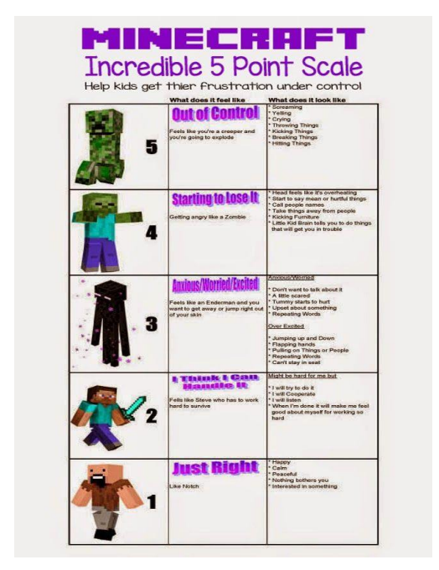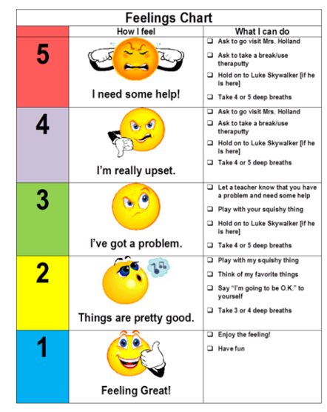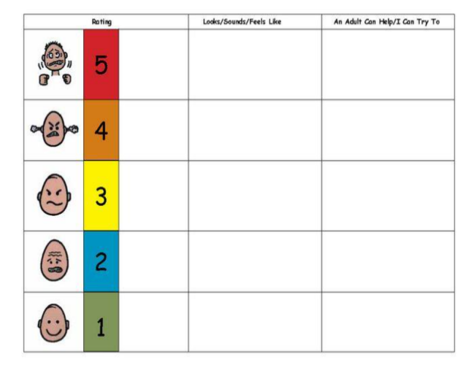
Appendix 10: Visual Timetables and Now and Next Boards

A visual timetable shows what is happening over a certain period of time in a visual way. It might use real photographs, cartoon pictures or symbols. It could show a short amount of time e.g. what is
happening now and what is going to happen next or it could show longer periods, such as the plan for part of, or all of the day. Simply, a visual timetable shows the plan, in pictures.

Why use a visual timetable?
Children and young people with language difficulties and or social communication difficulties often
have difficulties:
- Focusing their attention throughout the day
- Understanding their daily routine at home/school
- Moving (or transitioning) successfully and independently from one activity to another
- Remaining calm when they have to finish a preferred activity
- Remaining calm when they want to do an activity that they cannot do right now
- Coping with changes to their expected routine

How to Use a Visual Timetable
- At the beginning of the day, attach each symbol onto the visual timetable board with velcro/ blue tac in the order that it will be occurring throughout the day. At the beginning of the day/each session, explain the activities that will be taking place. Allow the pupil to ask any questions about the plan.
- Once each activity has been completed, return to the visual timetable and take the finished activity symbol off the visual timetable and place it in the ‘finished’ box/ envelope. This helps the pupil know where they are up to. It is important to be consistent with the timetable and to keep using it.

Our whole school visual classroom timetables
These are situated in every classroom on the side of large interactive screen and are therefore visible to everyone in the class.

Please see example below:

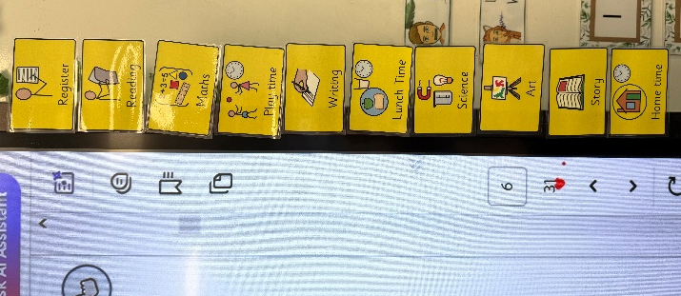

Now and Next Boards
A now and next board is a very much simplified visual timetable which has two activities or steps on it – what is happening now and what is happening next. This is useful for a child who isn’t yet developmentally ready for a visual timetable; is learning the concept and vocabulary for ‘now’ and ‘next’; or who has particular difficulty in moving from one activity to another.

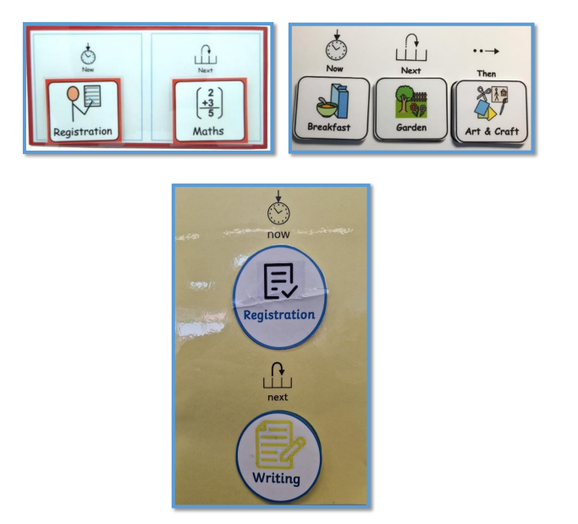

Appendix 11: House point System
All of our pupils are part of the house system and allocated to one of our four houses:
- Diamond
- Emerald
- Sapphire
- Ruby
We believe this gives our pupils an increased sense of community and belonging. Each point they earn individually is also a point for their house. These points are collected in containers displayed in a central areas of KS1 and KS2 for pupils to add theirs to the total. These are counted half termly and the winning house is celebrated in the newsletter and rewarding pupils in this house wearing their own clothes on the last day of school.
We aim to celebrate our pupils’ achievements in and out of school. We recognise the importance of attendance. House points can be earned for behaviour, attitude, effort, contribution, attendance and achievements in school.

Appendix 12: Back Chaining
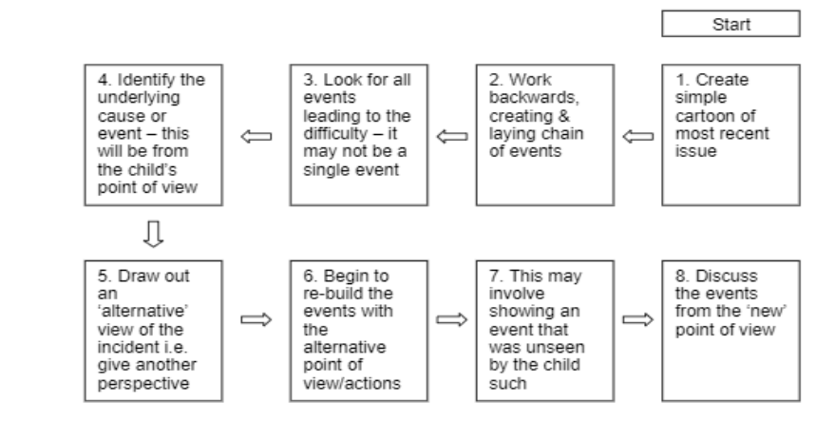

This is to be used with a child who may have difficulty in identifying the point at which a situation has gone wrong, or in identifying any perspective on a situation other than their own. Their perception of events may differ from those of other people involved in the incident, and therefore incidents, or reference to incidents may go on for some considerable time, furthering the breakdown of interaction with peers, and adding to the child’s anxieties. If a Pupil is having difficulty in understanding the events and interactions of a specific incident that has happened, and is causing distress use the back-chaining diagram above to support the child to explore the incident further.
Adult and Pupil draw a simple picture of the current situation (e.g. child angry). On a separate sheet they draw the incident that directly lead to that anger. At this point, don’t assume that this one incident had caused the anger.... Keep drawing pictures that go further back until a chain of events is established.
With the Pupil, identify where in particular the chain has gone wrong (this may be a single episode or a series of episodes). Draw an alternative picture for what should/could have happened instead, in other words, redraw the incident from an alternate perspective, perhaps that of the other peer involved (this may involve actually drawing out a picture showing that an incident had been dealt with, but which the child did not necessarily see, such as another peer being sanctioned). From the pictures of the other perspective, draw out the alternative sequence of events that would have happened from then on. In this way, the child can see any situations that they perceive have not been dealt with, or in which they cannot identify their own actions as having an effect on events. They can also identify where a specific event could have been dealt with differently, and that a different course of events would have resulted. Keep the back chain (stick in a book as necessary), as it not only shows that an incident has been dealt with, but will also serve as a record of any incidents which are recurring and may need further intervention through strategies such as Social Stories. If necessary, keep the ‘alternate’ (modelled) outcome for future reference and file the back-chain in a ‘finished’ box.

Appendix 13: De-escalation Strategies
- C.A.L.M—communicate, awareness, assessment, listen and look, make safe
- Distraction
- Reassurance
- Lowering voice/ broken record—’I am here to help.’
- Allowing space
- Humour
- Little challenge/ competition - ’I bet you can’t….’
- Planned ignoring
- Time out
- Reminder of what success looks like
- Verbal advice and support
- Showing pictures/ not too many words
- Change of adult
- Over and above recognition for doing the right thing / noticing a change in behaviour
- Emotion coaching—connect/ empathy
- Remove the class if children are in a potentially dangerous situation

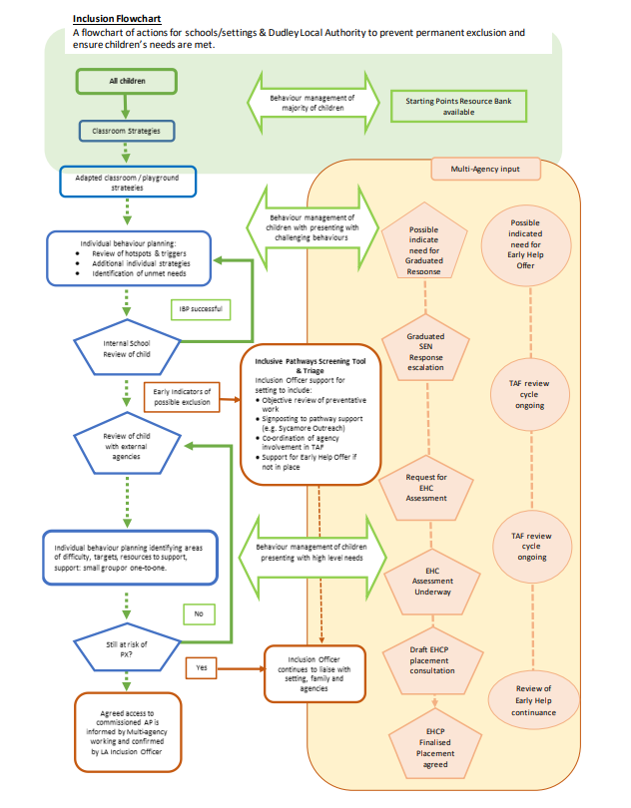
Appendix 14: Dudley Inclusive Pathways Flowchart
Appendix 15: Inclusion Flowchart and IP Screening Extension: CYP with EHCPs
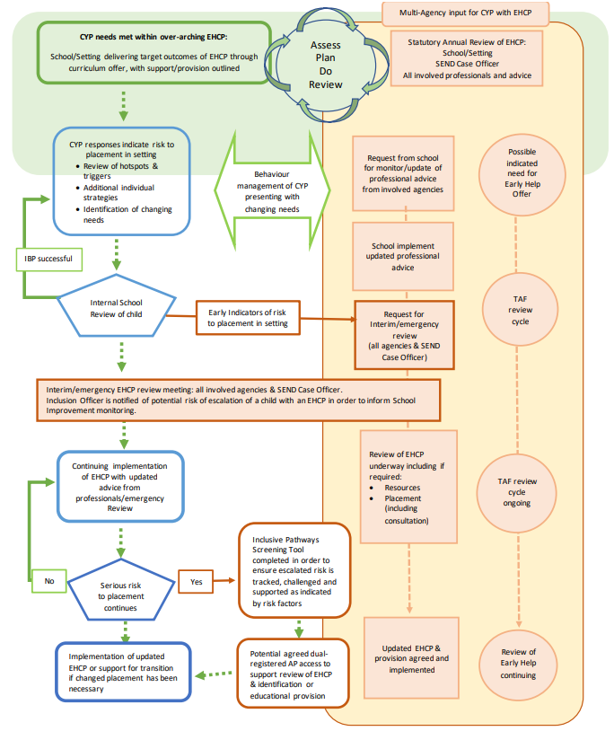
This flowchart combines Statutory Process and potential for Inclusive Pathways screening for CYP at risk of Exclusion. All settings are reminded that inability to meet need must not be a reason for Permanent Exclusion.
Appendix 16: Inclusive Pathways (IP) Screening Protocol
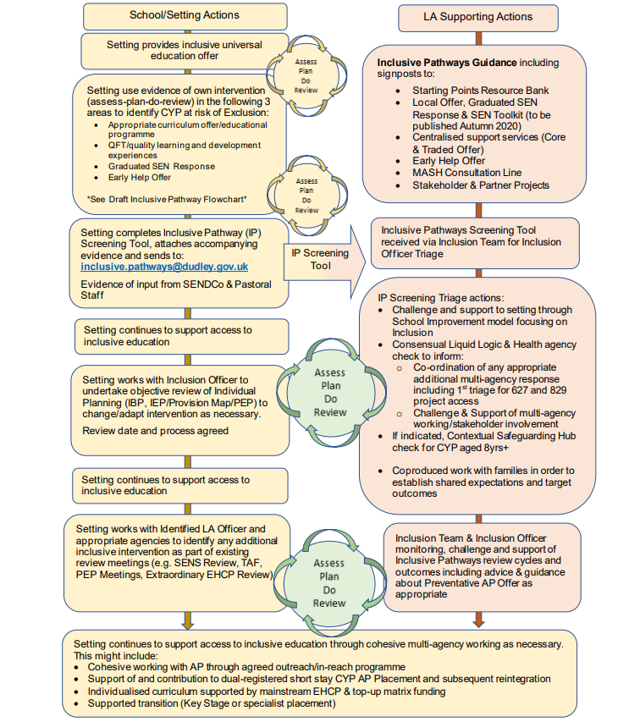
Appendix 17: Inclusive Education: Definitions and Principles
There is no agreed definition of inclusive education. It has often been associated with the rights of disabled people to be included in community schools, as in Article 24 of UN Convention of the Rights of Persons with Disabilities (2006). This states that disabled persons have the right to inclusive education. More recently international organisations have broadened the concept of inclusive education to include all potentially marginalised groups.
Thus, inclusive education is defined by UNESCO as “delivering education through common learning environments where all children and young people learn with their peers in community schools.” (Reaching Out to All Learners, 2016). While the UN 2030 Goals for Sustainable Development (2015) include the goal to “Ensure inclusive and equitable quality education and promote lifelong learning for all”. Within these broader definitions is the aim for inclusive education to eliminate social exclusion.
The following diagram from the UN Committee on the Rights of Persons with Disabilities is often used to illustrate inclusion:
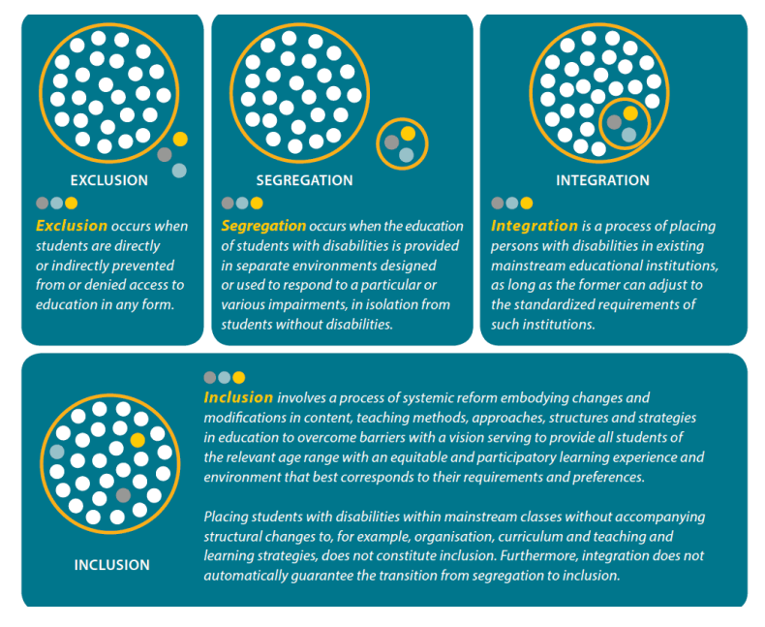
In Reaching Out to All Learners (2016) the International Bureau of Education defines inclusion in the following ways:
- Inclusion is a process. That entails that inclusion has to be seen as a never-ending search to find better ways of responding to Pupil diversity. It is about learning how to live with difference and learning how to learn from difference. In this way, differences come to be seen more positively as a stimulus for fostering learning among children and adults.
- Inclusion is concerned with the identification and removal of barriers. Here barriers may take different forms; some of which are to do with the way schools are organised, the forms of teaching provided and the ways in which children’s progress is evaluated. Consequently, it is necessary to collect, collate and evaluate evidence about these factors in order to plan for improvements in policy and practice. This involves using evidence of various kinds to stimulate creativity and problem-solving.
- Inclusion is about the presence, participation and achievement of all Pupils. Here ‘presence’ refers to where children are educated and how reliably and punctually they attend school; ‘participation’ relates to the quality of their experiences while they are present and therefore must incorporate the views of the learners themselves; and ‘achievement’ is about the outcomes of learning across the curriculum, not merely test or examination results.
- Inclusion involves a particular emphasis on those groups of learners who may be at risk of marginalisation, exclusion or underachievement. This indicates the moral responsibility to ensure that those groups that are statistically more at risk are carefully monitored and that -where necessary - steps are taken to ensure their presence, participation and achievement within the education system.

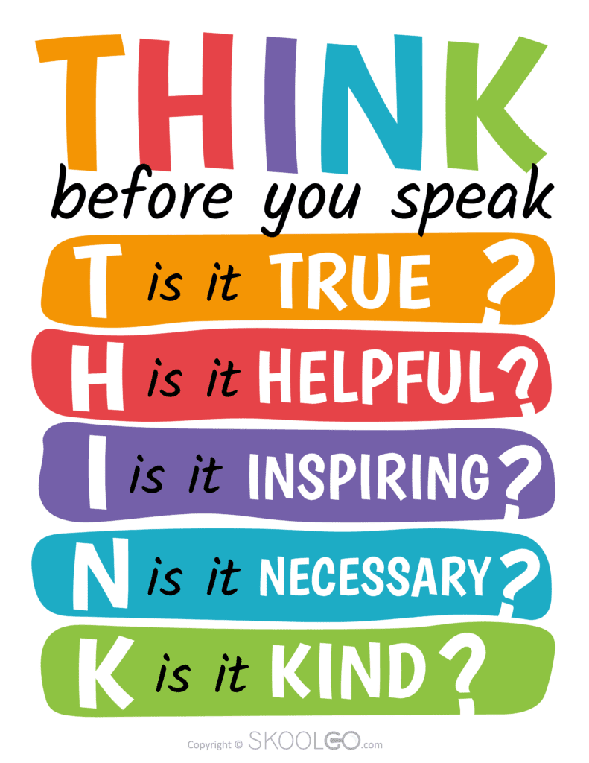
Appendix 18: THINK

Appendix 19: Expectations Posters (for example)
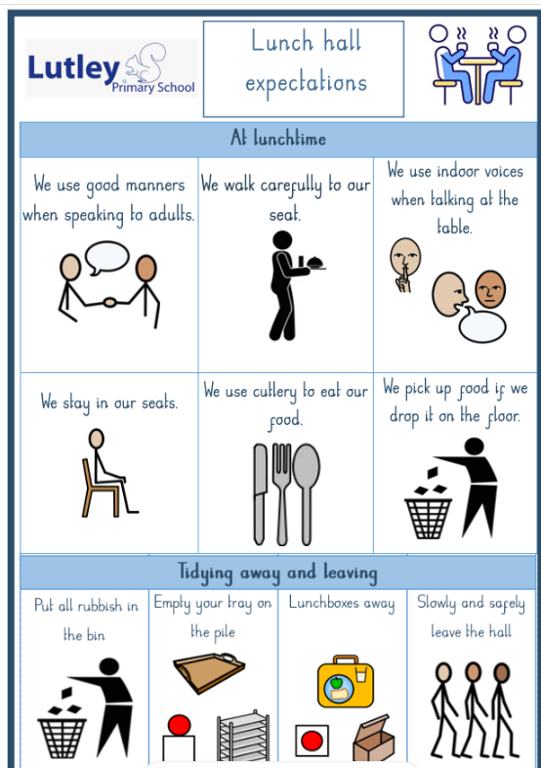
These exists for a variety of routines at Lutley which include: walking to and from assembly, walking to lunch, lunch hall behaviour, lining up at play time. Staff reinforce these through rehearsal and positive feedback. Classes are praised and noticed for being the best at walking through the building.
Appendix 20 Reflection Sheet
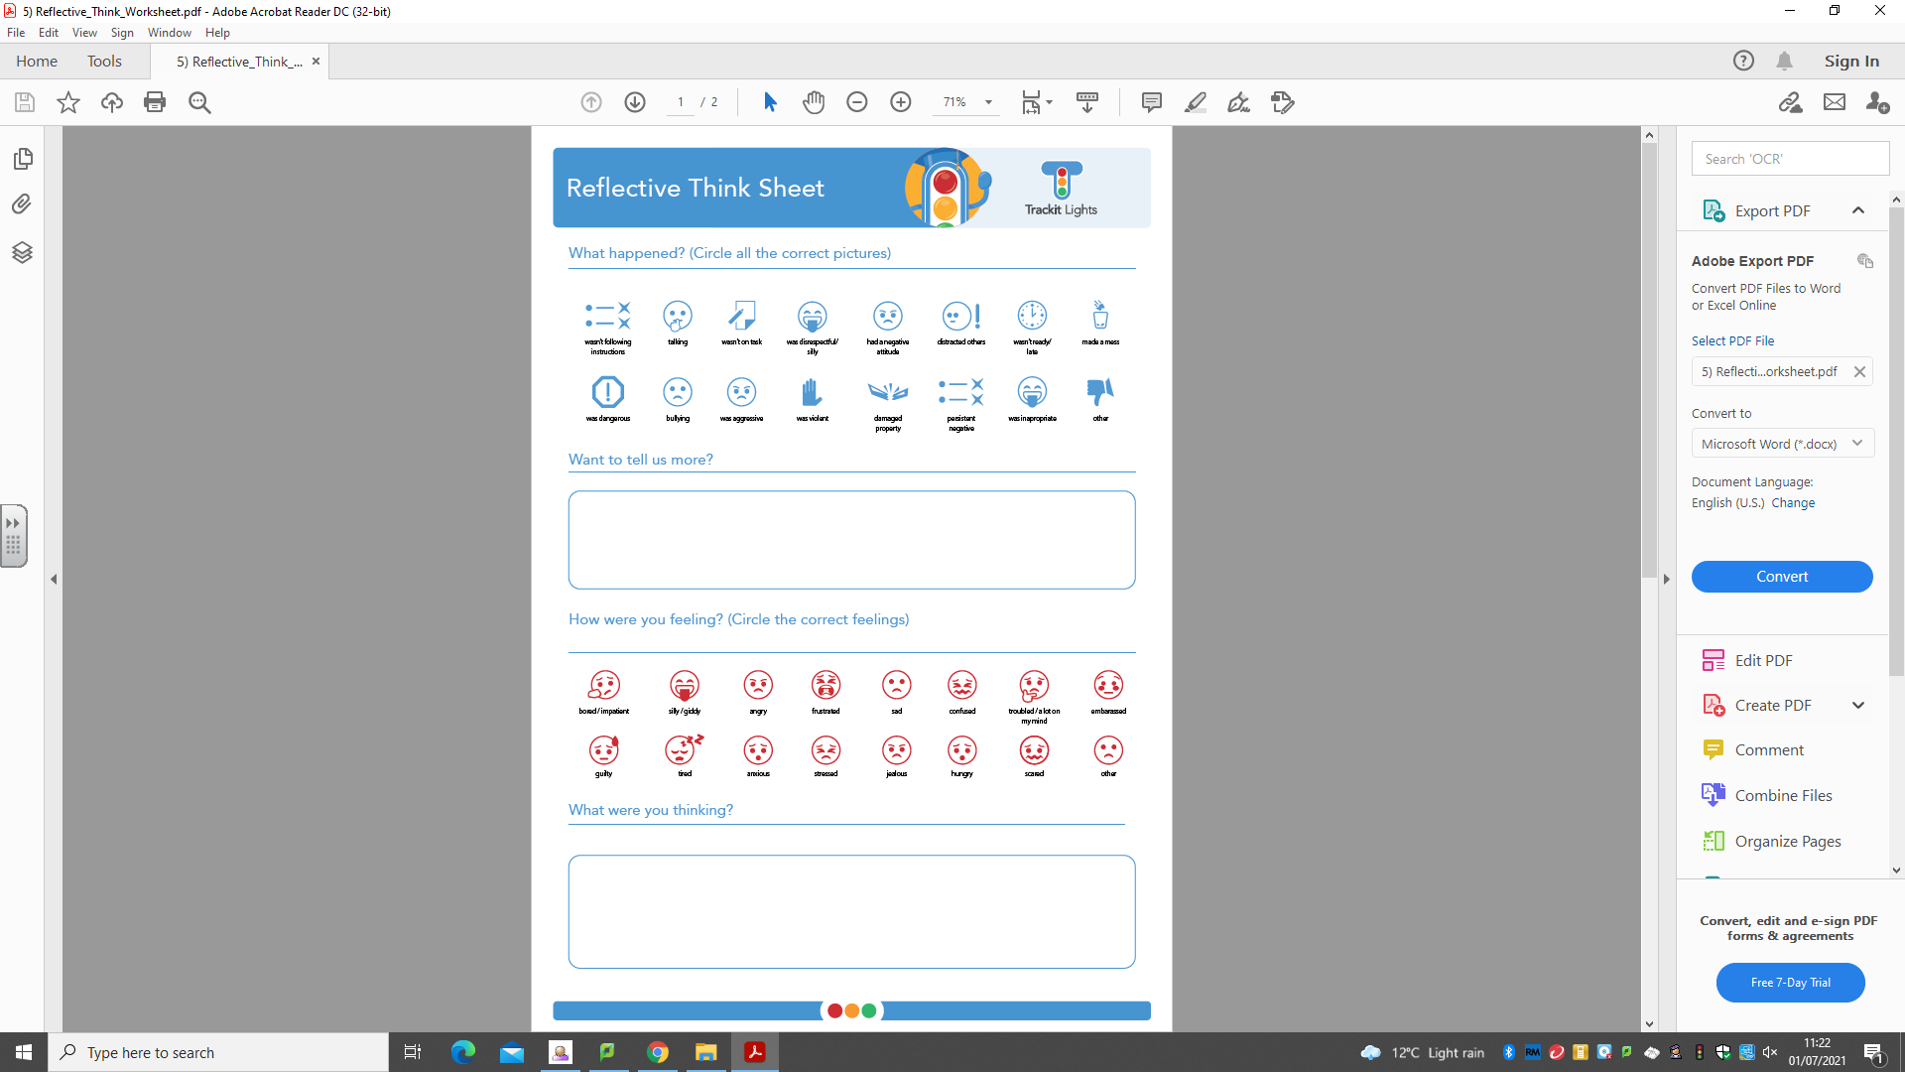
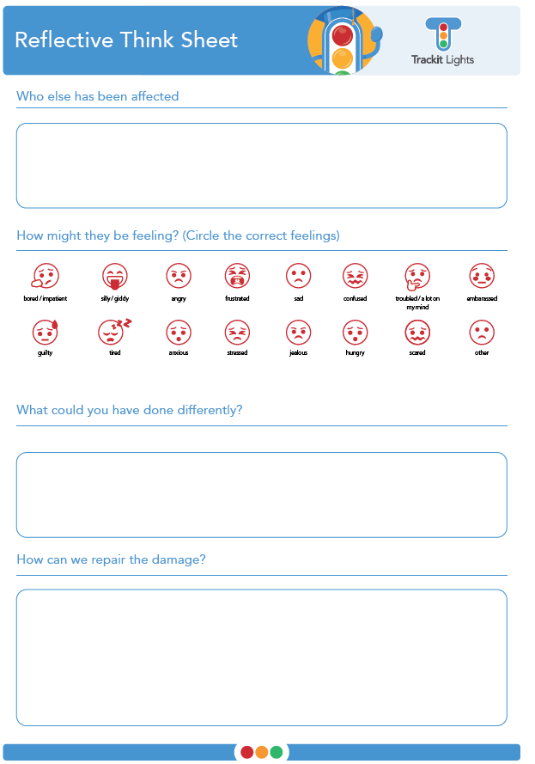

Appendix 21: New Pupil Induction
Children joining Lutley will be inducted by the Pastoral team and their class teacher to ensure that they make a smooth transition. As well as gaining important information from previous settings, children have an induction checklist to work through in their first two weeks.
New Pupil Induction Checklist
Name: | Date of Birth:
- Welcome and Orientation
- Warm welcome by key staff (class teacher, teaching assistant, pastoral lead, headteacher if possible).  - Tour of the school: classrooms, toilets, playground, lunch hall, library, quiet areas, and calm spaces (e.g., nurture or sensory room if applicable).  - Introduction to key adults: class teacher, TA, lunchtime staff, office staff, pastoral lead, SENCo if relevant. | 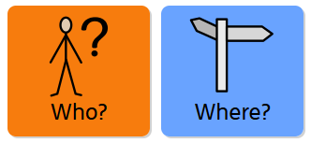
- Daily Routines

- Start and end of day routines: where to line up, drop-off/pick-up arrangements  - Timetable overview: clear explanation of what a typical day looks like.  - Break and lunch: timings, where to go, how to queue, eating arrangements (packed lunch/hot dinners), playtime expectations.  - Toilet routine: where they are, when they can go. | 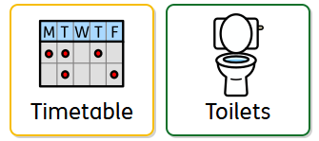
- Classroom Familiarisation
- Their peg, tray and desk  - Class rules and routines (e.g. lining up, putting hands up, transitions between lessons)  - Visual timetable shown and explained  - Introduction to classroom behaviour systems (e.g. recognition boards, traffic light systems, sticker charts) | 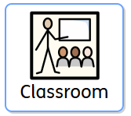
- Behaviour and Expectations
- Age-appropriate explanation of the school behaviour policy  - Zones of Regulation or emotion support tools, if used  - Rewards and recognition systems (e.g. Star of the Week)  - Calm spaces or support available if they are upset or worried | 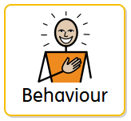
- Friendship and Belonging
- ‘Buddy’ system: assign a peer to support them at playtimes and around the classroom  - Group activities or games to help them get to know classmates  - Optional "All About Me" activity to share their interests and feel valued. | 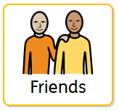
- Learning and Support
- Introduction to classroom tools and equipment (reading books, pencil pots, learning mats)  - Ask about preferred learning styles, areas they enjoy, or find difficult.  - Identify if any additional needs require adjustments (e.g. SEND support) | 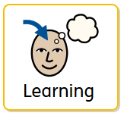
- Safeguarding and Safety
- Who to go to if they feel worried or unsafe  - Key safeguarding adult introduced (DSL/pastoral lead)  - Fire drill procedures (child-friendly version) | 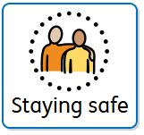
- Parental Involvement
- Induction pack or booklet sent home  - Parents invited for a brief meeting or ‘stay and play’ if appropriate  - Home-school communication explained (e.g. Parentmail, reading records, newsletter) | 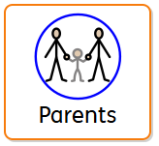

Appendix 22: ABC chart
ABC of Behaviour
Child’s name:
Date and Time & Name of adult comp  Which lesson was the child in / area of school? |  | Antecedent  What happened before?  (i.e. transition, factors at home, other child, words, instruction given?) | Behaviour  What was the behaviour?  Bullet point? Include anything that was said | Consequence  How will you reflect on your practice and what will you change?

Appendix 23: Biting
We always promote positive behaviour and recognise that all behaviour is a form of communication. Biting, while upsetting, is a common developmental behaviour among young children. It may occur for several reasons, including:
- Difficulty expressing emotions such as frustration, anger, or excitement
- Teething or a need for oral stimulation
- Sensory processing needs
- Attention-seeking behaviour
- Environmental overstimulation
- Special Educational Needs and/or Disabilities (SEND)
We treat every child as an individual and work closely with families to meet their specific needs. In responding to biting incidents, staff aim to understand the cause, support all children involved, and implement strategies to prevent recurrence.
Safeguarding Oversight
All biting incidents will be reviewed by the Designated Safeguarding Lead (DSL) to determine whether they raise any safeguarding or welfare concerns, particularly where patterns emerge or injuries are significant. The DSL will ensure all necessary follow-up actions align with the setting’s Safeguarding Policy and statutory duties under Keeping Children Safe in Education (2025).
Preventative Strategies
To reduce the likelihood of biting, staff use the following proactive measures:
- Facilitate small group interactions when needed to ensure every child receives individual attention.
- Provide designated quiet, cosy spaces for children who may feel overwhelmed.
- Use stories, social stories, puppets, and emotional literacy activities to help children recognise and express their feelings.
- Offer chewable accessories for children who require oral sensory stimulation.
- Ensure vigilant and responsive staff who can identify and respond to individual behavioural cues.
- Maintain sufficient resources and duplicate toys where possible to minimize conflicts.
- Encourage positive behaviour through reinforcement and gentle coaching of social skills.
- Deliver annual training for all staff on behaviour management, infection control, safeguarding, and understanding of developmental behaviours such as biting. The Designated Safeguarding Lead (DSL) and Senior Leadership Team (SLT) are responsible for ensuring that all training is current, recorded, and reviewed in line with statutory requirements.
- Increase supervision of children who exhibit biting behaviours, which may not require one-to-one monitoring but can be targeted during specific times or by reducing large group activities.
- Provide significant encouragement for positive behaviour in children who bite, while avoiding excessive attention after incidents.
- Regularly assess routines to ensure they meet children’s needs, offering engaging indoor and outdoor activities without long waiting times; group activities should be purposeful rather than serving as a holding strategy.
- Plan a sequence of activities designed to release frustration and promote calmness, such as outdoor physical play followed by calming sensory experiences like play dough or gloop.
- Create cosy areas for relaxation and provide activities that help relieve tension, including water play, sand digging, and sensory equipment.
For children with additional needs or frequent biting behaviour, staff will adapt strategies accordingly and may seek further advice from professionals or specialist services.
Responding to Biting Incidents
Recording, Reporting and Data Protection
All biting incidents will be recorded in accordance with setting procedures (e.g., accident forms, CPOMS). Records will include the date, time, location, and children involved, and will be stored securely under UK GDPR and the Data Protection Act 2018. Information will only be shared with relevant staff and parents/carers on a need-to-know basis.
When a Child is Bitten
- Immediate Response
- Comfort the child and provide emotional reassurance
- Wear gloves and check for visible injury
- If the skin is broken, allow the wound to bleed gently, clean with warm water, and dress appropriately
- Monitor the area for signs of infection and consult with relevant medical staff if needed
- Reporting
- Complete a MediTracker/Accident Form/Medical Book entry, including date, time, and inform the child’s parents or carers. Where appropriate, a phone call will be made to inform the parent/carer after the incident and before collection time.
- Record the incident on CPOMS, including date, time, and names of children involved
- Designated first aider to be consulted if required
- Confidentiality
The identity of the child who bit will not be disclosed to other parents, in order to protect the privacy and dignity of all children involved and to avoid potential conflict. However, parents/carers will be informed of the actions taken in response to the incident, without mentioning any names.
When a Child Bites Another Child
- Immediate Response
- Speak to the child calmly, using positive, age-appropriate language
- Reassure the child if they are distressed and check for any injury
- Clearly explain that biting is not acceptable and can hurt others
- Encourage empathy by asking the child how they can help make the other child feel better
- Follow-Up Actions
- Complete an incident form and inform the child’s parents at the end of the session
- Observe the child to identify potential triggers (e.g., tiredness, frustration, sensory overload)
If biting continues:
- Arrange a meeting with the child’s parents to develop a behaviour support plan
- The child may be discreetly shadowed by a staff member for short intervals (e.g. 10 minutes) to prevent incidents and gather behavioural observations
- Parents may be advised to seek further professional support if necessary
- SEND and High-Risk Cases
- If biting is linked to SEND or repeated behaviour, a risk assessment will be completed. An individual risk assessment will identify triggers, control measures, and review timelines. The assessment will be reviewed regularly with input from the SENDCo, parents, and external professionals (if involved) to ensure measures remain proportionate and effective.
- Where appropriate, recommendations may include immunisation (e.g., hepatitis B) for staff or children in line with health advice
- Additional professional input may be sought to support the child and setting
When Skin is Broken or There Is a Risk of Infection
- If the skin is broken, follow first aid guidance: allow bleeding, clean with warm water, dress the wound. Seek advice from the designated first aider
- Parent/Carer to be informed and advice seeking medical attention

In cases involving potential blood-borne viruses (BBVs):
The Headteacher / Head of School must inform both sets of parents and recommend medical advice
- If a staff member with a BBV is bitten, appropriate reporting and safeguarding procedures will be followed
- Any biting incident resulting in hospital treatment will be reported under RIDDOR. Any biting incident resulting in an injury requiring hospital treatment, or where infection risk is significant, will be reported to the Health and Safety Executive (HSE) under the Reporting of Injuries, Diseases and Dangerous Occurrences Regulations (RIDDOR 2013). The DSL and SLT will ensure that all infection control guidance from UK Health Security Agency (UKHSA, formerly Public Health England) is followed.

If a Member of Staff is Bitten
- Assess the injury and administer first aid
- If the skin is broken, follow infection control procedures
- Seek advice or support from medical staff if needed
- Complete an Accident Report with the Office Manager and file it in the staff member’s record
- If there is a known BBV risk, the staff member should seek immediate medical attention
- The incident should be reported to the Senior Leadership Team to determine any further steps
- Any biting incident resulting in hospital treatment will be reported under RIDDOR

SEND and Equality Duty
We are committed to meeting our obligations under the Equality Act 2010 and the SEND Code of Practice (2015). This means:
Reasonable Adjustments: We will make reasonable adjustments to ensure that children with Special Educational Needs and/or Disabilities (SEND) are not placed at a substantial disadvantage. This may include:
- Providing adult support during high-risk times.
- Offering alternative calming strategies or sensory resources.
- Adapting the environment to reduce triggers (e.g., quieter spaces, visual supports).
- Implementing personalised behaviour support plans in collaboration with parents and relevant professionals.

Inclusive Practice: All responses to biting incidents will consider the child’s individual needs, developmental stage, and any identified SEND. We will avoid punitive measures and focus on supportive, restorative approaches.
Monitoring and Review: Behaviour support plans and risk assessments for children with SEND will be reviewed regularly to ensure effectiveness and fairness.
In line with our duties under the Equality Act 2010 and the SEND Code of Practice, we recognise that some behaviours, including biting, may be a form of communication for children with Special Educational Needs and Disabilities (SEND). We are committed to making reasonable adjustments to ensure that no child is placed at a substantial disadvantage due to a disability. This includes adapting our responses, interventions, and support strategies to meet individual needs. Our approach is anticipatory and inclusive, ensuring that behaviour policies are applied with flexibility and understanding. We work closely with families, external professionals, and our SENDCo to ensure that any behavioural incidents are addressed in a way that is fair, proportionate, and supportive of the child’s development and well-being. This policy aligns with our Public Sector Equality Duty to eliminate discrimination, advance equality of opportunity, and foster good relations among all pupils.
Monitoring and Review
All biting incidents will be monitored termly by the Senior Leadership Team (SLT) and Designated Safeguarding Lead (DSL) to identify patterns, triggers, and evaluate the effectiveness of interventions. Behaviour support plans and risk assessments will be reviewed accordingly. This policy will be reviewed annually, or sooner if there are changes to statutory guidance (e.g. EYFS or KCSIE).
Working with Parents and Carers
We are committed to maintaining open, respectful communication with all families:
- Parents of the child who has bitten are supported to understand the behaviour and reassured that strategies are being implemented to help their child
- Parents of the child who has been bitten are informed promptly and reassured that the incident has been handled appropriately and confidentially
- Meetings will be arranged as needed to share updates and plans moving forward
- No blame is placed on the child or family; our focus is always on support and resolution

This policy complies with the Statutory Framework for the EYFS (2025), Keeping Children Safe in Education (2024), and relevant health and safety legislation

Biting is often a communication tool; we're here to help children find their words and express their needs in a safe way.

The guidance on biting should be read alongside the Behaviour Policy, Safeguarding Policy, and SEND Policy to ensure a consistent and legally compliant approach to behaviour management and child welfare.

Appendix 24: Sources of Support
Taken from DfE Respectful School Communities Self Review and Signposting Tool

Ethos and values
Government documents
Name | Description | Link
What maintained schools must publish online | The information that schools maintained by their local authorities must publish on their websites, including values and ethos. | https://www.gov.uk/guidance/what-maintained-schools-must-publish- online
What academies, free schools and colleges should publish online | What information academies (including 16 to 19 colleges and any educational institution that has academy arrangements) should publish on their websites, including values and ethos. | https://www.gov.uk/guidance/what-academies-free-schools-and- colleges-should-publish-online
Other resources
Organisation | Description | Link
UNICEF | Rights Respecting Schools Award (RRSA): UNICEF works with schools in the UK to create safe and inspiring places to learn, where children are respected, their talents are nurtured and they are able to thrive. The Rights Respecting Schools Award embeds these values in daily school life and gives children the best chance to lead happy, healthy lives and to be responsible active citizens. | https://www.unicef.org.uk/rights-respecting-schools

Behaviour

Government documents
Name | Description | Link
Behaviour and discipline in schools – statutory guidance for governing bodies | Guidance for school governing bodies on their role in creating their school's behaviour policy. | https://www.gov.uk/government/publications/behaviour-and- discipline-in-schools-guidance-for-governing-bodies
Behaviour and discipline in schools | Guidance for school leaders and staff on developing a school behaviour policy, and a checklist of actions to take to encourage good behaviour.  This page also shows Charlie Taylor’s checklists on the basics of classroom management. Teachers can use it to develop between five and ten essential actions to encourage good behaviour in pupils. | https://www.gov.uk/government/publications/behaviour-and- discipline-in-schools
Use of reasonable force in schools | Guidance about the use of physical restraint in schools for governing bodies, head teachers and school staff. | https://www.gov.uk/government/publications/use-of-reasonable- force-in-schools
Searching, screening and confiscation at school | Guidance explaining the powers schools have to screen and search pupils, and to confiscate items they find. | https://www.gov.uk/government/publications/searching- screening-and-confiscation
Mental health and behaviour in schools | Non-statutory, departmental advice to help schools support pupils whose mental health problems manifest themselves in behaviour. | https://www.gov.uk/government/publications/mental-health-and- behaviour-in-schools--2

Other resources
Organisation | Description | Link
Tom Bennett (independent review on behaviour in schools) | ‘Creating a Culture: How school leaders can optimise behaviour’ includes strategies to manage behaviour and a series of case studies which cover all types of schools. | https://www.gov.uk/government/publications/behaviour-in- schools
ASK Research | Report which includes 20 case studies of schools that have succeeded in improving behaviour. The case studies highlight common approaches implemented across these schools which have helped to develop a culture which optimises learning, good behaviour and social skills for its pupils. The report includes schools rated ‘outstanding’ by Ofsted in the period 2014 to 2015. | https://www.gov.uk/government/publications/school-behaviour- management-case-studies-report
ITT Behaviour Review Panel | To understand what constitutes good, core teacher training, school leaders could look at the findings of this review panel, which include a skeleton set of training standards. | https://www.gov.uk/government/publications/initial-teacher- training-government-response-to-carter-review
Young Minds | Addressing Adversity is about prioritising adversity and trauma-informed care for children and young people in England. | https://youngminds.org.uk/media/2142/ym-addressing-adversity- book-web.pdf

Anti-bullying

Government documents
Name | Description | Link
Preventing and tackling bullying | Guidance for schools on preventing and responding to bullying. | https://www.gov.uk/government/publications/preventing-and- tackling-bullying
Approaches to preventing and tackling bullying | Research into anti-bullying practices used by schools to prevent and tackle bullying, including case studies. | https://www.gov.uk/government/publications/approaches-to- preventing-and-tackling-bullying

Other resources
Organisation | Description | Link
Anti-Bullying Alliance | A coalition of organisations and individuals united against bullying. They run programmes focused on specific aspects of bullying behaviour which are available for schools to access, along with a library of online resources for schools.  Their support for schools includes free CPD-certified online training for professionals (developed using funding from the Department for Education) as part of their All Together programme. Funding from the DfE will run until March 2020. | https://www.anti-bullyingalliance.org.uk/
Diana Award | The Diana Award’s Anti-Bullying Campaign involves projects aimed at reducing bullying in schools, including the Anti-Bullying Ambassadors programme which trains young people to lead on anti-bullying campaigns in their schools.  DfE are providing funding toward the anti-bullying ambassador training, to keep it free for schools until March 2020. | https://diana-award.org.uk/anti-bullying/
Internet Matters | Internet Matters were set up to help keep children safe in the digital world. Their website includes an online safety resource hub with information for use in the classroom and to help parents make positive changes to children’s digital lives.  DfE are providing funding towards the Make a Noise programme to keep it free for schools until January 2019. | https://www.internetmatters.org/issues/cyberbullying/
The Anne Frank Trust UK | The Anne Frank Trust use education to create a society safe from prejudice and discrimination. They partner with schools, local authorities, the criminal justice sector and others to deliver educational programmes which empower young people with the knowledge, skills and confidence to challenge prejudice and discrimination.  DfE are providing funding towards the Free to Be training to keep it free for schools until March 2020. | https://annefrank.org.uk/education/

Anti-bullying

Other resources
Organisation | Description | Link
Childnet | The cyber-bullying guidance provides advice for schools on understanding, preventing and responding to cyberbullying. There is an online safety toolkit which helps schools deliver sessions through PSHE about cyberbullying, peer pressure and sexting. | http://www.childnet.com/our-projects/cyberbullying-guidance- and-practical-toolkit
Youth Sport Trust – Play Unified | Play Unified uses the power of sport to promote inclusive and tolerant school communities built on understanding, acceptance and friendship among young people. | http://www.playunified.org/
Kidscape | Kidscape provide children, families, carers and professionals with advice, training and practical tools to prevent bullying and protect young lives. | https://www.kidscape.org.uk/
Royal Foundation – Stop Speak Support Campaign | A cyberbullying campaign which includes packs for schools to use to introduce the campaign to their pupils. The packs encourage young people to think twice about how they respond to cyberbullying. | https://www.stopspeaksupport.com/schools
SkillForce | SkillForce is a national education charity looking into how character and resilience is taught and delivered in schools. | https://www.skillforce.org/about/
National Education Union | Details of training and CPD courses which contribute to creating inclusive, respectful and safe school environments. | https://neu.org.uk/learning
Equality and Human Rights Commission | Practical guidance on creating an anti-bullying culture. It includes information about ways for pupils and staff to report bullying incidents, recording and reviewing data, and communicating anti-bullying messages. | https://www.equalityhumanrights.com/en/publication-download/ using-data-inform-and-evaluate-anti-bullying-strategies
 | The Equality and Human Rights Commission and the Anti-Bullying Alliance have developed tips for schools on how to reduce discriminatory bullying. | https://www.equalityhumanrights.com/en/advice-and-guidance/ how-can-we-stop-prejudice-based-bullying-schools

Safeguarding

Government documents
Name | Description | Link
Keeping children safe in education | Statutory guidance for schools and colleges on safeguarding children and safer recruitment. | https://www.gov.uk/government/publications/keeping-children- safe-in-education--2
Working together to safeguard children | Statutory guidance on inter-agency working to safeguard and promote the welfare of children. | https://www.gov.uk/government/publications/working-together- to-safeguard-children--2
Child abuse concerns: guidance for practitioners | Guidance to help practitioners identify the signs of child abuse and neglect, and understand what action to take. | https://www.gov.uk/government/publications/what-to-do-if- youre-worried-a-child-is-being-abused--2
Sexual violence and sexual harassment between children in schools and colleges | Advice for schools and colleges on how to prevent and respond to reports of sexual violence and harassment between children. | https://www.gov.uk/government/publications/sexual-violence- and-sexual-harassment-between-children-in-schools-and- colleges
Information sharing advice for safeguarding practitioners | Guidance on information sharing for people who provide safeguarding services to children, young people, parents and carers. | https://www.gov.uk/government/publications/safeguarding- practitioners-information-sharing-advice
UK Council for Internet Safety | The UK Council for Internet Safety expands the scope of the UK Council for Child Internet Safety to achieve a safer online experience for all users, particularly groups who suffer disproportionate harms. The website has useful resources for schools and parents to help keep children safe online. | https://www.gov.uk/government/groups/uk-council-for-child- internet-safety-ukccis

Other resources
Organisation | Description | Link
Childnet | Project DeShame tackles peer-based online sexual harassment among 13 to 17 year olds by empowering local communities (including schools and police) to work together to increase reporting among young people. | https://www.childnet.com/our-projects/project-deshame
NSPCC | Pants (The Underwear Rule) campaign resources for schools and teachers. | https://www.nspcc.org.uk/preventing-abuse/keeping-children- safe/underwear-rule/underwear-rule-schools-teaching-resources/
Internet Matters | Information, advice and useful resources that can be shared with parents with children that may have participated in sexting. | https://www.internetmatters.org/issues/sexting/

Special educational needs and disabilities

Government documents
Name | Description | Link
SEND code of practice | Guidance on the special educational needs and disability system for children and young people aged 0 to 25. | https://www.gov.uk/government/publications/send-code-of- practice-0-to-25
SEN support: research evidence on effective approaches and examples of current practice in good and outstanding schools and colleges | Provides leaders, teachers and practitioners with access to information about evidence- based practice that can be effective for SEN support. | http://www.sendgateway.org.uk/resources.sen-support-research- evidence-on-effective-approaches-and-examples-of-current- practice-in-good-and-outstanding-schools-and-colleges.html

Other resources
Organisation | Description | Link
NASEN – SEND Gateway | An online portal offering education professionals free access to high quality information, resources and training for meeting the needs of children with special educational needs and disabilities. | http://www.sendgateway.org.uk/
Childnet | The Childnet STAR Toolkit is a new online safety resource that offers practical advice and teaching activities to help secondary schools explore internet safety with young people with autism spectrum disorders. | http://www.childnet.com/resources/star-toolkit/respect

Equality Act and the Public Sector Equality Duty

Government documents
Name | Description | Link
Equality Act 2010: advice for schools | Guidance to help schools understand how the Equality Act affects them and how to fulfil their duties under the act. | https://www.gov.uk/government/publications/equality-act-2010- advice-for-schools

Other resources
Organisation | Description | Link
Equality and Human Rights Commission | A guide to help school leaders meet the equality duty. It describes some of the benefits that the equality duty can bring. The focus is on the practical implementation of the equality duty in schools. | https://www.equalityhumanrights.com/en/publication-download/ public-sector-equality-duty-guidance-schools-england
 | Guidance dealing with the school’s provisions of the Equality Act 2010 and explaining what you must do to meet the requirements of equality law. | https://www.equalityhumanrights.com/en/publication-download/ what-equality-law-means-you-education-provider-schools
Inclusion Quality Mark | Inclusion Quality Mark provides schools with a nationally recognised framework to guide their inclusion journey. | https://iqmaward.com/
LBGTQ+
Barnardo’s | Its LGBTQ hub offers guidance to young people, parents and teachers on how to support LGBT pupils and tackle LGBT prejudice-based bullying. | http://www.barnardos.org.uk/what_we_do/our_work/lgbtq.htm
EACH (Educational Action Challenging Homophobia) | Provides a national free action line for targets of homophobic or transphobic bullying, as well as training for schools on sexual orientation, gender identity matters and cyberhomophobia. | https://www.eachaction.org.uk/
LGBT consortium | Resources to support schools prevent HBT bullying from happening in the first place, effectively respond to HBT bullying when it does occur, and create an inclusive school environment for LGBT pupils and families. | https://www.pshe-association.org.uk/lgbt-consortium
Metro Charity | An equality and diversity charity, providing health, community and youth services. Metro works with anyone experiencing issues related to gender, sexuality, diversity or identity. | https://www.metrocentreonline.org/
The Proud Trust | Helps young people empower themselves to make a positive change for themselves and their communities through youth groups, peer support, training and events, campaigns, research and resources. | https://www.theproudtrust.org/
Schools Out | Offers practical advice, resources (including lesson plans) and training to schools on LGBT equality in education. | http://www.schools-out.org.uk/
Stonewall | An LGBT equality organisation with considerable expertise in LGBT bullying in schools, a dedicated youth site, resources for schools, and specialist training for teachers. | http://www.stonewall.org.uk/

LBGTQ+
LGBT History Month | LGBT History Month is celebrated in February in the UK. Each year, The Proud Trust teams up with Schools OUT UK and LGBT History Month to write a simple education and resource pack. | https://lgbthistorymonth.org.uk/  https://www.theproudtrust.org/training-and-education/education- resources/lgbt-history-month/
Diversity Role Models | Diversity Role Models actively seeks to prevent homophobic, biphobic and transphobic bullying in UK schools. They educate young people about difference, challenging stereotypes and addressing the misuse of language. | https://www.diversityrolemodels.org/
Just Like Us | A national network of university student volunteers who can visit secondary schools to share their stories, bust stereotypes and explain why LGBT+ equality is everyone’s issue. | http://www.justlikeus.org/
Race, religion and nationality
Show Racism the Red Card | Provide resources and workshops for schools to educate young people, often using the high profile of football, about racism. | http://www.srtrc.org/educational
Kick It Out | Uses the appeal of football to educate young people about racism and provide education packs for schools. | http://www.kickitout.org/
Tell MAMA | Measuring Anti-Muslim Attacks (MAMA) allows people from across England to report any form of anti-Muslim abuse, MAMA can also refer victims for support through  partner agencies. | http://tellmamauk.org/
Stand Up! | Stand Up! was established in 2016 to provide anti-discrimination education to young people in mainstream schools, with a focus on antisemitism and anti-Muslim hate.  Supported by the Ministry of Housing, Communities and Local Government, Stand Up! combines Streetwise and Maccabi GB’s experience in delivering personal development sessions to thousands of young people in school settings with CST and Tell MAMA’s respective expertise in monitoring, recording and combating antisemitism and  anti-Muslim hate. | https://www.standupeducation.org/
Gender
UK Feminista | The UK Feminista resource hub contains templates, policy guidance and classroom activities to support schools to tackle sexism. Resources include how to take a whole school approach to tackling sexism and sexual harassment, tips for secondary school teachers, tips for primary school teachers, and a policy integration guide. | https://ukfeminista.org.uk/resources-hub
Against Violence and Abuse | The prevention platform has been created to support education practitioners across the UK deliver a programme to stop violence against women and girls. It contains accredited e-learning, template policies and resources. | http://www.preventionplatform.co.uk/
For special educational needs and disabilities resources see the separate table above

PE and sport

Government documents
Name | Description | Link
National curriculum in England: PE programmes of study | The statutory programmes of study and attainment targets for physical education at Key Stages 1 to 4. | https://www.gov.uk/government/publications/national-curriculum- in-england-physical-education-programmes-of-study

Other resources
Organisation | Description | Link
Youth Sport Trust – Play Unified | Play Unified uses the power of sport to promote inclusive and tolerant school communities built on understanding, acceptance and friendship among young people. | http://www.playunified.org/
Youth Sport Trust – My Personal Best | My Personal Best aims to develop life skills, leadership and employability skills in young people such as empathy, teamwork and resilience. This award-winning support package (DfE Character Awards 2016 — regional winner) is designed to inspire secondary PE teachers to confidently teach life skills. | https://www.youthsporttrust.org/mypersonalbest
Youth Sport Trust – Girls Active | Girls Active supports schools to understand what motivates girls to take part in physical activity. It enables teachers to work with girls to make the necessary changes to their physical education and sport provision. It is developed by the Youth Sport Trust, delivered in partnership with This Girl Can and Women in Sport, and funded by Sport England. | https://www.youthsporttrust.org/girls-active
Youth Sport Trust – Top Sportsability | TOP Sportsability is a free online resource for schools and offers practical advice to teachers, learning support staff and other sports practitioners. It consists of video clips and downloadable content showing ideas and strategies around to include young disabled people in physical activity. | https://www.youthsporttrust.org/top-sportsability
School Games – Inclusive Health Check | A self-review tool available to School Games registered schools, school games organisers, and local organising committees on an annual basis. It helps users improve best practice, access key resources, and develop an action plan. | https://www.yourschoolgames.com/how-it-works/inclusive-sport/

Relationships Education, RSE, Health Education and PSHE

Government documents
Name | Description | Link
Government guidance is currently being updated, we will include a link once available
Public Health England | Website with videos made by young people and resources tested with teachers about online and offline relationships and bullying, alcohol, smoking, stress, and body image. | https://campaignresources.phe.gov.uk/schools/topics/rise-above/ overview?WT.mc_id=RiseAboveforSchools_PSHEA_EdComs_ Resource_listing_Sep17
 | The Child and Maternal Health Intelligence Network brings together publically available data, information, reports, tools and resources on child and maternal health in to one easily accessible hub. | https://fingertips.phe.org.uk/profile/child-health-profiles

Other resources
Organisation | Description | Link
PSHE Association | The national body for personal, social, health and economic education, providing expert advice, training and high-quality resources to PSHE practitioners. | https://www.pshe-association.org.uk/
 | Abuse in relationships: Disrespect NoBody. | https://www.pshe-association.org.uk/curriculum-and-resources/ resources/disrespect-nobody-teaching-resources-preventing
 | Consent lesson plans. | https://www.pshe-association.org.uk/curriculum-and-resources/ resources/guidance-teaching-about-consent-pshe-education-key
 | Mental health and emotional wellbeing lesson plans. | https://www.pshe-association.org.uk/curriculum-and-resources/ resources/guidance-preparing-teach-about-mental-health-and
 | The PSHE association have also quality assured a number of resources developed as part of the GEO anti-HBT bullying grant scheme. | https://www.pshe-association.org.uk/content/government- equalities-office-anti-homophobic
NSPCC | Resources about making sense of relationships. | https://learning.nspcc.org.uk/research-resources/schools/ making-sense-relationships/
Youth Sport Trust – Get Exam Fit | A package of support to help pupils build confidence, manage their physical and emotional wellbeing and achieve their potential in school exams. | https://www.youthsporttrust.org/search?search=get+exam+fit
Catholic Education Service | Example of model curriculum for primary and secondary. | http://catholiceducation.org.uk/schools/relationship-sex-education
Sexwise | Sexual health and relationships resources. | https://sexwise.fpa.org.uk/
Mentor-ADEPIS | Research and briefing papers with ideas for lessons about drug and alcohol education. | http://mentor-adepis.org/planning-effective-education/

Fundamental British values

Government documents
Name | Description | Link
Promoting fundamental British values through SMSC | Departmental advice on promoting the important British values as part of pupils’ spiritual, moral, social and cultural (SMSC) development. | https://www.gov.uk/government/publications/promoting- fundamental-british-values-through-smsc
Protecting children from radicalisation: the Prevent duty | Guidance for schools and childcare providers on preventing children and young people from being drawn into terrorism. | https://www.gov.uk/government/publications/protecting-children- from-radicalisation-the-prevent-duty

Other resources
Organisation | Description | Link
Educate Against Hate | This website gives teachers, parent and school leaders practical advice and information on protecting children from extremism and radicalisation. | http://www.educateagainsthate.com
Internet Matters | Information on radicalisation that explains the issue and provides links to several organisations that can provide further help and support. | https://www.internetmatters.org/issues/radicalisation/
Equality and Human Rights Commission -Equal Rights, Equal Respect | Free online teacher training and education resources to help teach Key Stage 3 pupils about equality and human rights. | https://www.equalityhumanrights.com/en/secondary-education- resources
 | Guidance on delivering the Prevent duty in a proportionate and fair way. | https://www.equalityhumanrights.com/sites/default/files/ delivering-the-prevent-duty.pdf

Computing

Government documents
Name | Description | Link
National curriculum in England: computing programmes of study | Statutory guidance on computing programmes of study. | https://www.gov.uk/government/publications/national-curriculum- in-england-computing-programmes-of-study/national-curriculum- in-england-computing-programmes-of-study

Other resources
Organisation | Description | Link
NSPCC | Online safety resources for schools. | https://www.nspcc.org.uk/preventing-abuse/keeping-children- safe/share-aware/teaching-resources/
Internet Matters | Dedicated section for school professionals about internet safety. It includes resources to share with parents and a searchable database of helpful resources to support training, classroom activities and policy. | https://www.internetmatters.org/schools-esafety/
Children’s Commissioner for England | Report about social media. | https://www.childrenscommissioner.gov.uk/wp-content/ uploads/2018/01/Childrens-Commissioner-for-England-Life-in- Likes-3.pdf

The arts

Government documents
Name | Description | Link
National curriculum in England: music programmes of study | The statutory programmes of study and attainment targets for music at Key Stages 1 to 3. | https://www.gov.uk/government/publications/national-curriculum- in-england-music-programmes-of-study/national-curriculum-in- england-music-programmes-of-study
National curriculum in England: art and design programme of study | The statutory programmes of study and attainment targets for art and design at Key Stages 1 to 3. | https://www.gov.uk/government/publications/national-curriculum- in-england-art-and-design-programmes-of-study

Other resources
Organisation | Description | Link
Artsmark | Artsmark is a framework for planning, delivering and evaluating arts, culture and creativity across the curriculum. | https://www.artsmark.org.uk/
Arts Council | Funded by DfE, music education hubs are groups of organisations working together to create joined-up music education provision. | https://www.artscouncil.org.uk/music-education/music- education-hubs

Citizenship

Government documents
Name | Description | Link
Citizenship programmes of study: Key Stages 1 and 2 | Guidance about teaching citizenship in England. | https://www.gov.uk/government/publications/citizenship- programmes-of-study-for-key-stages-1-and-2
Citizenship programmes of study: Key Stages 3 and 4 | Guidance about teaching citizenship in England. | https://assets.publishing.service.gov.uk/government/uploads/ system/uploads/attachment_data/file/239060/SECONDARY_ national_curriculum_-_Citizenship.pdf
National Citizen Service: guidance for schools and colleges | NCS is for 16 and 17 year olds in England. It helps build skills for work and life, while participants take on new challenges and meet new friends. | https://assets.publishing.service.gov.uk/government/uploads/ system/uploads/attachment_data/file/657812/National_Citizen_ Service-Guidance_for_Schools_and_Colleges_.pdf
 |  | https://www.gov.uk/government/get-involved/take-part/national- citizen-service

Other resources
Organisation | Description | Link
Association for Citizenship Teaching | The professional subject association for citizenship education. | https://www.teachingcitizenship.org.uk/home

Case studies

Area | Name | Description | Link
Behaviour and culture | ASK Research | Report which includes 20 case studies of schools that have succeeded in improving behaviour. The case studies highlight common approaches implemented across these schools which have helped to develop a culture which optimises learning, good behaviour and social skills for its pupils. The report includes schools rated ‘outstanding’ by Ofsted in the period 2014 to 2015. | https://www.gov.uk/government/publications/school-behaviour- management-case-studies-report
Anti-bullying | Approaches to preventing and tackling bullying | Research into anti-bullying practices used by schools to prevent and tackle bullying, including case studies. | https://www.gov.uk/government/publications/approaches-to- preventing-and-tackling-bullying
 | How schools can use data to prevent and tackle bullying | Real-life examples of how eight primary, secondary and special schools across Britain gather, analyse and use data to prevent and tackle prejudice-based bullying. | https://www.equalityhumanrights.com/en/advice-and-guidance/ how-can-schools-use-data-prevent-and-tackle-bullying#case
Wellbeing | Mental health and wellbeing provision in schools | Review of published policies and information to look at the extent to which the content of schools’ published policies and other information demonstrates relevant approaches to mental health and wellbeing in schools. | https://www.gov.uk/government/publications/mental-health-and- wellbeing-provision-in-schools
Mental health | Supporting mental health in schools and colleges | Survey and case studies with schools on activities to support pupils’ mental health and wellbeing. | https://www.gov.uk/government/publications/supporting-mental- health-in-schools-and-colleges
Sexual harassment and sexual violence | Sexual violence and sexual harassment between children in schools and colleges | Case studies showing how schools have effectively implemented preventative education and how schools have dealt with reports of sexual harassment or sexual abuse are included within this advice. | https://www.gov.uk/government/publications/sexual-violence- and-sexual-harassment-between-children-in-schools-and- colleges
SEND | SEN support: research evidence on effective approaches and examples of current practice in good and outstanding schools and colleges | Provides leaders, teachers and practitioners with access to information about evidence-based practice that can be effective for SEN support. | http://www.sendgateway.org.uk/resources.sen-support-research- evidence-on-effective-approaches-and-examples-of-current- practice-in-good-and-outstanding-schools-and-colleges.html

